Cricket Player Performance
Tracking Application :
CRICKSTATS
Project work Submitted in partial fulfillment of the requirements
for the award of the degree of

Bachelor of Computer Applications
to
THIRUVALLUVAR UNIVERSITY, SERKKADU,
VELLORE-632115
By

A.NAZEMA [Reg No: 30424U09017]V.SANDHIYA [Reg No: 30424U09025]
G.RAJARAJESWARI [Reg No: 30424U09015]
P.ROSHINI [Reg No: 30424U09035]

Guest Lecturer in Computer Applications



OCTOBER-2026

ARIGNAR ANNA GOVT. ARTS COLLEGE FOR WOMEN WALAJAPET - 632513

(AFFILIATED TO THIRUVALLUVAR UNIVERSITY)

Smart Match Performance, Daily Practice Monitoring and Growth
Analysis

User Story:
As a Cricket Coach, I want to use CRICKSTATS to manage player profiles and match performances in one place and track each player’s statistics after every match. I want to check today’s player performance, compare it with previous performances, and plan tomorrow’s matches or training sessions. I also want to use team-wise player insights, automated performance summaries, player comparison, reports, and dashboards to understand player progress and make team selection and planning easier for the next match.
1.INTRODUCTION
1.1 Project Overview :
CRICKSTATS is a smart system designed for cricket coaches. Through this application, coaches can manage player profiles and match performances in a single platform. It is very useful for tracking player statistics after every match and comparing today's performance with previous performances. Similarly, tomorrow's matches and training sessions can be planned effectively. Coaches can easily understand player progress through team-wise player insights, automated performance summaries, player comparisons, reports, and dashboards. This helps make the team selection and planning process for the next match very simple.
1.2 Purpose :
- To manage player profiles in one place.
- To record and track player match performances.
- To monitor player statistics after every match.
- To compare current and previous performances.
- To identify player strengths and weaknesses.
- To provide team-wise player insights.
- To generate automated performance summaries.
- To compare players based on their statistics.
- To generate performance reports and dashboards.
- To help coaches select players for the next match.
- To plan upcoming matches and training sessions.
- To track overall player progress.

2. IDEATION PHASE
2.1 Problem Statement (Customer Problem Statement Template)
Problem Statement (PS) | I am (Customer) | I’m trying to | But | Because | Which makes me feel
PS-1 | A Cricket Coach | Track player performance after every match | I cannot easily monitor all player statistics | Match records are maintained separately | Frustrated and concerned
PS-2 | A Team Manager | Manage complete player profiles and records | It takes too much time to update player details | Player information is stored in different places | Stressed and inefficient
PS-3 | A Sports Analyst | Compare player performances and analyse trends | I cannot easily compare previous and current performances | There is no centralized performance analysis | Confused and dissatisfied
PS-4 |  | Plan training sessions based on player performance | I cannot easily identify each player’s improvement areas | Performance data is not available in one dashboard | Worried and time-consuming
  A Fitness Trainer

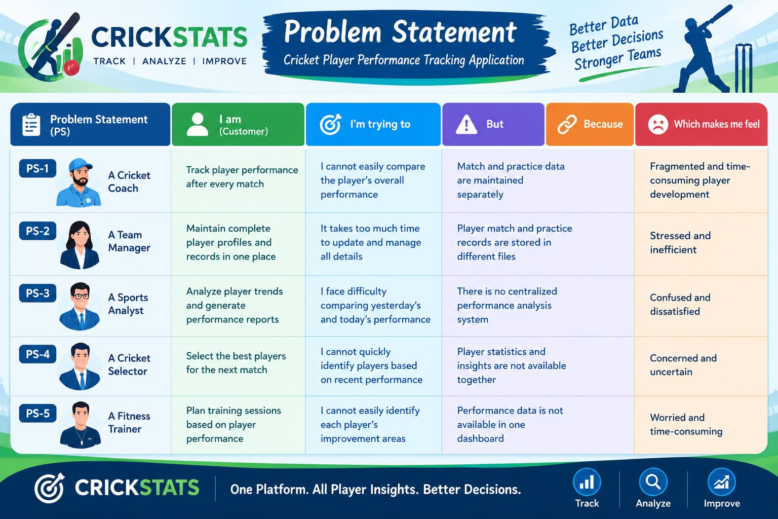

2.2 Empathy Map Canvas

Target Users
- Cricket Team Coach
- Team Manager
- Sports Analyst
- Cricket Selector
- A Fitness Trainer

Empathy Analysis

Aspect | Description
Says | Wants to manage player profiles and match performances in one place and easily check today’s performance, player comparisons, and automated summaries to plan the next match.
 | Needs reliable player statistics and team-wise insights after every match to make smarter team selections and training plans.
  Thinks
Feels | Eager to support player progress, nut overwhelmed by the challenge of handling scattered statistics, reporting, and planning manually.
Uses | Manages player profiles, tracks match statistics, checks dashboards, compares player data, and plans training sessions or matches.
Pains | Difficulty keeping track of individual statistics across matches, comparing data manually, and spending too much time trying to organize player progress for team selection.
Gains | A centralized platform (CRICKSTARS) with automated performance summaries, dashboards, player comparisons, and clear insights for seamless team planning and selection.

2.3 Brainstorming
Brainstormed Ideas
- Centralized Player Profile Manager
- Match-by-Match Performance Tracking
- Automated Performance Summaries
- Daily Player Evaluation Dashboard
- Yesterday VS Today Comparison
- Player Consistency Analysis
- Training Planner / Training Session Planner
- Customizable Dashboards
- Coach/Mate Reports
- Smart Team Selection Tool
- Customizable Reports & Dashboards
- Player Profile Dashboards

Selected Idea: Cricket Player Performance Tracking Application

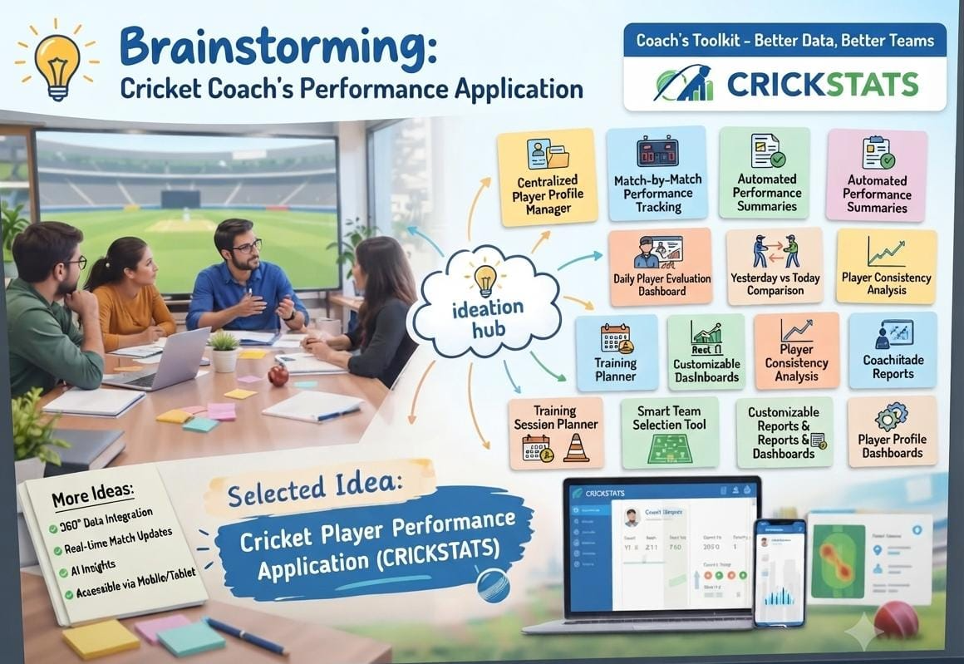

3.REQUIREMENT ANALYSIS PHASE

3.1 Customer Journey Map
Journey Stages:
- System OnBoarding & Setup
- Player Profile Management
- Pre-Match Squad Review & Intelligence
- Player Comparison & Evaluation
- Team Selection & Final Strategy
- Live Match & Post-Match Data Logging
- Today’s Performance vs. Previous Trends Analysis
- Automated Report Generation
- Training Session & Practice Planning
- Continuous Progress Tracking & Future Strategy

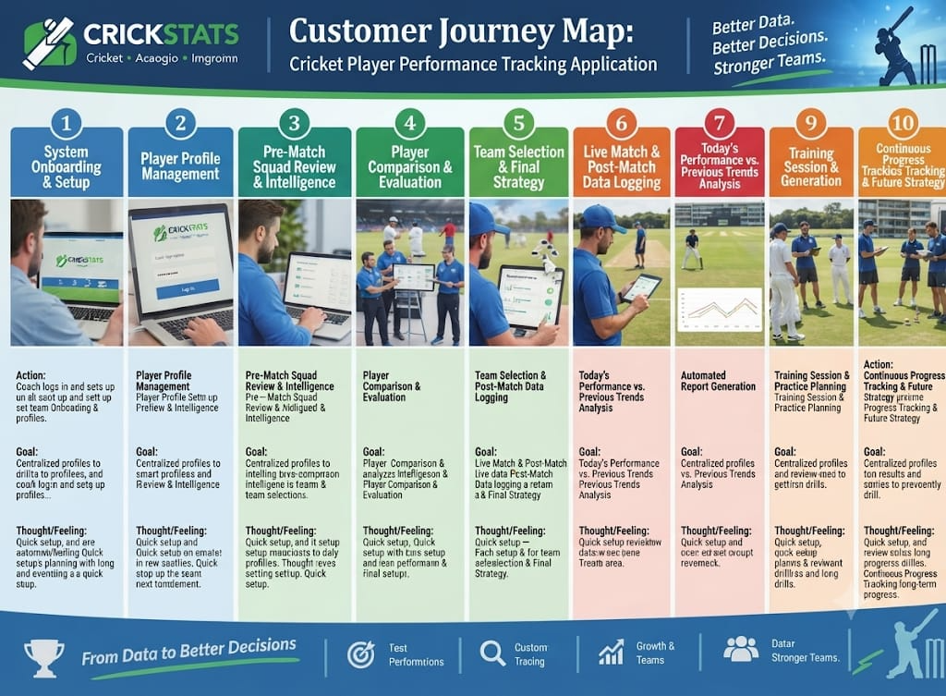

3.2 Solution Requirements
Functional Requirements
FR No | Requirement
FR-1 | Player Registration
FR-2 | Match Performance Entry
FR-3 | Dashboard Generation
FR-4 | Report Creation
FR-5 | Flow Automation

Non-Functional Requirements (NFRs) – CRICKSTATS

NFR-1: Performance & Speed
The system should load player dashboards and generate performance summaries quickly without noticeable delay during peak usage.
Requirements
- Fast data retrieval for match-by-match statistics
- Instant generation of automated performance summaries
- Smooth navigation between customizable dashboards
Examples:
- View today's player evaluation dashboard in under 2 seconds
- Switch between different player profiles instantly without lagging
Example: Cricbuzz or apps provide real-time match statistics updates and instant player stat retrieval without delay.

NFR-2: Security
The system should restrict unauthorized access to sensitive player records, coach reports, and team selection data.
Requirements
- Role-based access control for coaches, admins, and players
- Secure login authentication for viewing coach/mate reports
- Protection of private team strategies and performance insights
Examples:
- Log in securely to access exclusive team-wise player insights and private reports without data leakage risks
Example: Firebase Authentication and role-based access control (RBAC) securely manage user permissions for coach and admin portals.

NFR-3: Reliability & Data Accuracy
The system should ensure high accuracy and reliable storage of player statistics and match data without data loss.
Requirements
- Secure storage for centralized player profiles
- Accurate calculation and comparison for yesterday vs. today metrics
- Reliable backup of post-match entry logs
Example:
- Match performance entries are saved securely without corruption
- Historical comparisons and consistency analysis data remain accurate over time
Example: Cloud database systems like AWS RDS or Google Cloud SQL maintain automated data backups and ensure zero data loss for critical performance records.
NFR-4: Usability
The system should be easy to understand and use by coaches, managers, and analysts without requiring complex technical training.

Requirements
- Simple and intuitive user interface
- Clear navigation menus
- Easy-to-read dashboards and reports
- Minimal learning curve for daily operations
Example:
Log in, enter match statistics, and view player reports within a few minutes without special training.
Easily switch between different team insights and customizable dashboards.
Example: Modern sports analytics platforms like Hudl or standard sports management apps provide clean, drag-and-drop interfaces and user-friendly forms for quick data entry.
NFR-5: Scalability
The system should efficiently handle an increasing number of players, matches, and historical data over multiple seasons without affecting system performance.
Requirements
- Ability to handle growing data volumes for match-by-match tracking
- Seamless addition of new teams and player profiles
- Consistent query and report generation speed as the database grows
Example:
Add multiple new player profiles and match records across several seasons without system slowdowns.
Retrieve historical consistency analysis data smoothly even with years of stored information.
Example: Cloud-hosted databases with auto-scaling capabilities (like MongoDB Atlas or AWS DynamoDB) allow applications to expand storage and handle increasing user loads seamlessly.
NFR-6: Maintainability
The system should be easy to update, fix, and maintain by developers without causing downtime to the core player tracking and reporting features.
Requirements
- Modular code architecture for separate components like player profiles, dashboards, and automated summaries
- Easy integration of new features or updates to match statistics tools
- Proper error logging and debugging support for system administrators
Example:
Deploy new updates or bug fixes to the dashboard modules without interrupting active user sessions.
Integrate new data fields or tracking metrics smoothly into existing player records.

3.3 Data Flow Diagram
Data Flow
User (Cricket Coach) ➔ CRICKSTATS UI ➔ Player Profile ➔ Match Performance ➔ Reports ➔ Dashboard
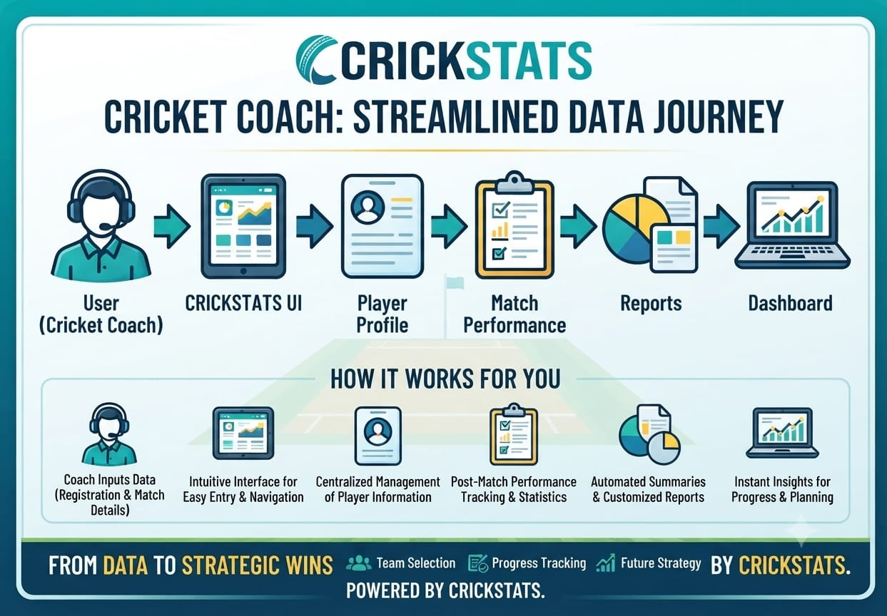

3.4 Technology Stack
Layer | Technology
Frontend | Salesforce Lightning
Analytics | Reports & Dashboards
Automation | Salesforce Flows
Backend | Salesforce Objects
Database | Salesforce Cloud

4. PROJECT DESIGN PHASE
4.1 Problem and Solution Fit
The CRICKSTATS application addresses the primary challenges faced by cricket coaches who traditionally struggle with scattered data, manual record-keeping, and the absence of a centralized platform to manage player profiles and track match-by-match performances. Without instant access to comparative analytics, such as contrasting yesterday's performance with today's, coaches find it difficult to evaluate progress accurately, plan effective training sessions, or make confident, data-driven decisions for team selection. To solve this, CRICKSTATS offers an all-in-one Salesforce-powered ecosystem that consolidates player management and performance tracking into a single interface. By integrating automated performance summaries, real-time dashboards, and targeted analytics, the platform eliminates tedious paperwork and empowers coaches to seamlessly monitor player development, streamline match preparation, and optimize team strategies.

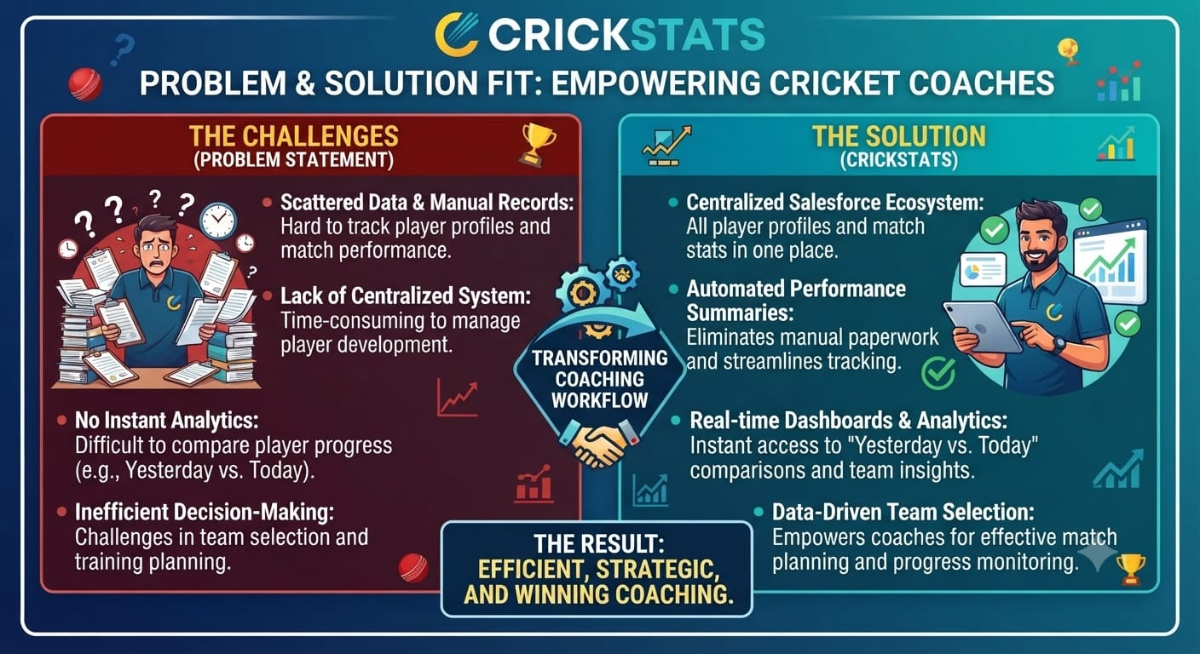

4.2 Proposed Solution
Description
- CRICKSTATS is an all-in-one, Salesforce-powered performance management application built specifically for cricket coaches.
- It serves as a centralized digital ecosystem designed to eliminate scattered records and manual paperwork.
- The platform streamlines player profiling, match-by-match data logging, and advanced analytics into a single interface.
- It empowers coaches to track player development effortlessly, compare performances, and make confident, data-driven decisions.

Key Features

Centralized Player Profile Manager: Allows coaches to register, store, and manage all player profiles, personal details, and career histories in one secure, accessible location.

Match-by-Match Performance Tracking: Enables seamless entry and tracking of individual and team statistics immediately after every match.

Real-Time Dashboards & Comparative Analytics: Provides instant visibility into player performance through dynamic dashboards, featuring vital comparative metrics like "yesterday vs. today" to accurately measure progress.

Automated Performance Summaries: Leverages Salesforce automation to automatically generate match summaries and performance reports, saving valuable time for the coaching staff.

Team-Wise Insights & Selection Support: Delivers comprehensive team insights and player comparisons to simplify the process of strategizing training sessions and choosing the best playing eleven.

4.3 Solution Architecture
Architecture Layers
- Presentation Layer (Frontend)
- Business Logic & Automation Layer
- Data & Application Layer (Backend)
- Analytics & Reporting Layer
- Storage & Cloud Infrastructure
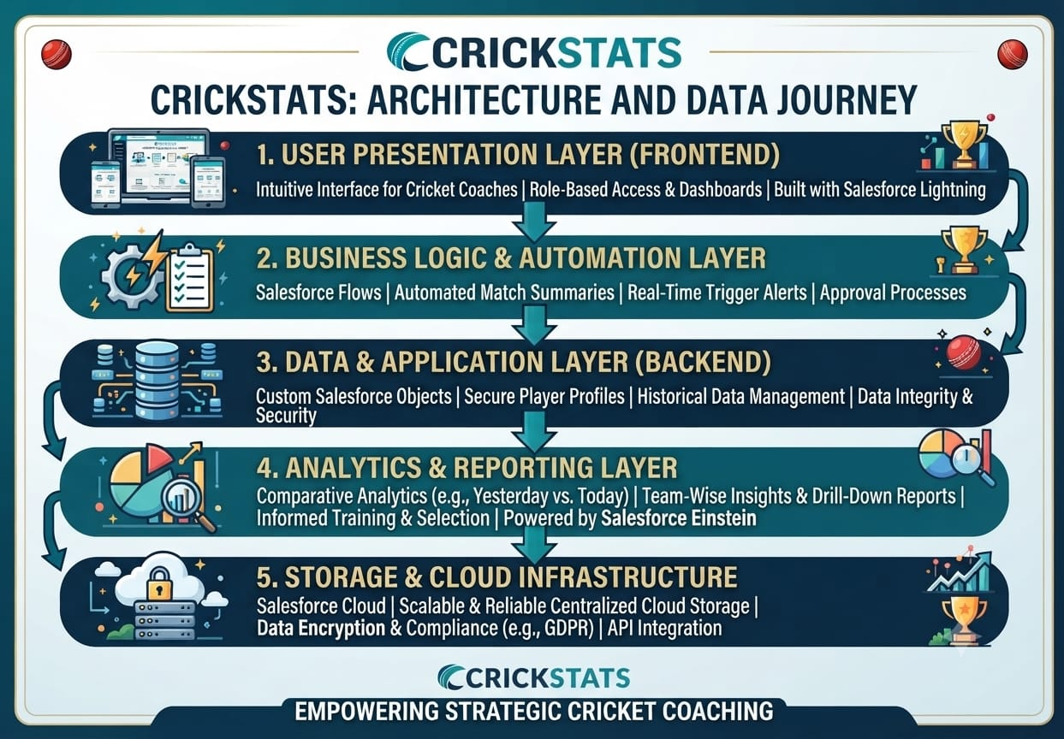

5. PROJECT PLANNING & SCHEDULING

5.1 Project Planning
- User Story & Acceptance Criteria
- Data Model & custom Objects
- Automation & Workflow Design
- Reporting & Analytics Framework
- Testing & Deployment Strategy

Product Backlog, Sprint Schedule, and Estimation (4 Marks)
Use the below template to create product backlog and sprint schedule
Sprint | Functional Requirement (Epic) | User Story Number | User Story / Task | Story Points | Priority | Team Members
Sprint-1 | Profile Management | USN-1 | As a coach, I want to create and store player profiles and details in a single secure place so that records are organized. | 3 | High | Member1
Sprint-1 | Match Tracking | USN-2 | As a coach, I want to log match-by-match statistics immediately after a match so that individual progress is tracked. | 5 | High | Member2
Sprint-2 | Performance Analysis | USN-3 | As a user, I want to check today’s player performance and compare it with previous performances to measure growth. | 5 | High | Member1
Sprint-2 | Planning & strategy | USN-4 | As a coach, I want to use automated performance summaries and reports to plan tomorrow’s training session. | 3 | High | Member2
Sprint-3 | Insights & Dashboards | USN-5 | As an admin, I want to view team-wise player insights and dashboardsto make team selection easier for the next match. | 8 | Medium | Member1

Project Tracker, Velocity & Burndown Chart: (4 Marks)
Sprint | Total Story Points | Duration | Sprint Start Date | Sprint End Date (Planned) | Story Points Completed (as on Planned End Date) | Sprint Release Date (Actual)
Sprint-1 | 20 | 6 Days | 05 Oct 2026 | 10 Oct 2026 | 20 | 10 Oct 2026
Sprint-2 | 20 | 6 Days | 12 Oct 2026 | 17 Nov 2026 | 20 | 17 Oct 2026
Sprint-3 | 20 | 6 Days | 19 Oct 2026 | 19 Oct 2022 | 18 | 25 Oct2026
Sprint-4 | 20 | 6 Days | 26 Oct 2026 | 31 Oct 2022 | 20 | 31 Oct2026

6. Project Development Phase:

Project Flow

Milestone 1 - developer account creation
Milestone 2 – Player Profile Management
Milestone 3 – Match Performance Recording
Milestone 4 – Player–Performance Relationship
Milestone 5 – Automated Performance Summary
Milestone 6 – Today’s Performance Tracking
Milestone 7 – Previous Performance Comparison
Milestone 8 – Player Comparison & Team Insights
Milestone 9 – Coach Performance Flow
Milestone 10 – Performance Reports
Milestone 11 – Coach Dashboard
Milestone 12 – Tomorrow Match / Training Planning
Milestone 13 – Team Selection

Implementation

Milestone 1 - developer account creation :

Activity 1: Creating Developer Account

- Creating a developer org in salesforce.
- Go to https://developer.salesforce.com/signup
- On the sign up form, enter the following details :

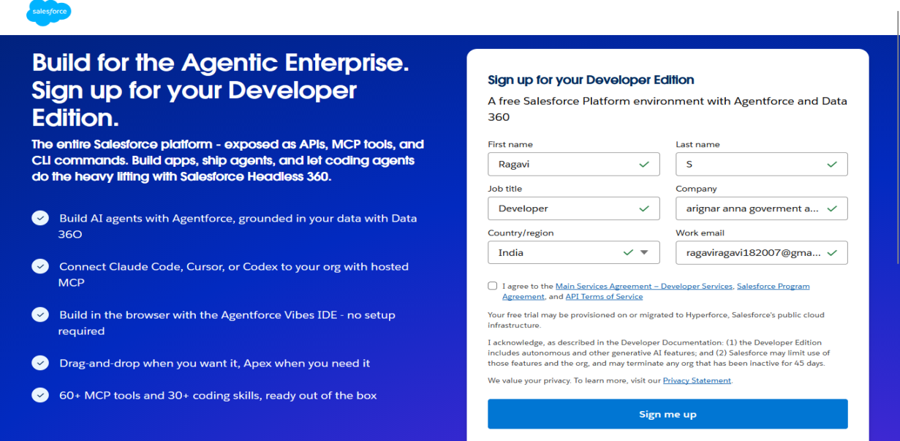

- First name & Last name
- Email
- Role : Developer
- Company : College or Company Name
- County : India
- Postal Code : pin code
- Username : should be a combination of your name and company
This need not be an actual email id, you can give anything in that format : username@organization.com
Click on sign me up after filling these.

Activity 2: Account Activation

Go to the inbox of the email that you used while signing up. Click on the verify account to activate your account.
- The email may take 5-10mins.
- Click on Verify Account.

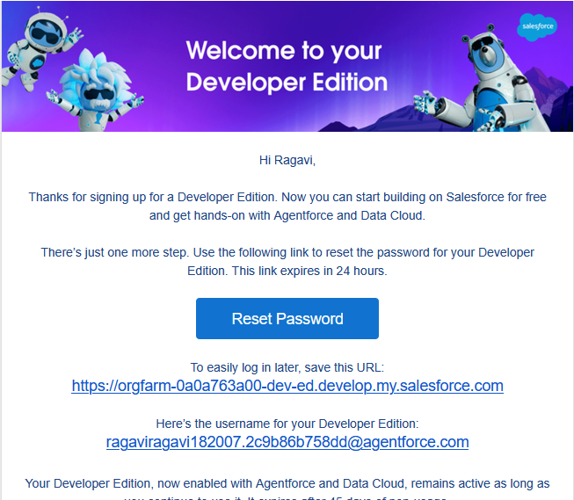

- Give a password and answer a security question and click on change password.

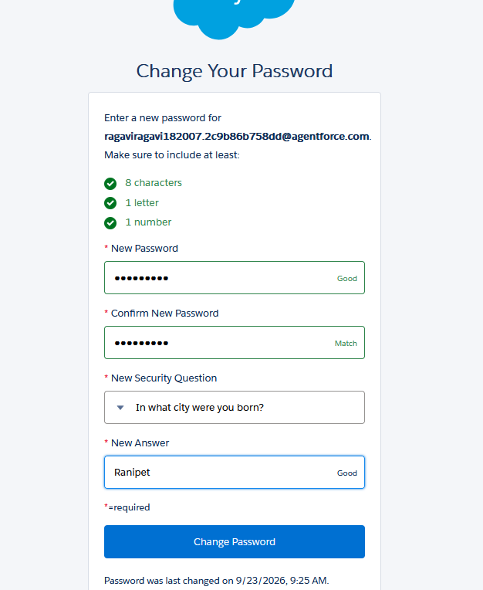

- Then you will redirect to your salesforce setup page.

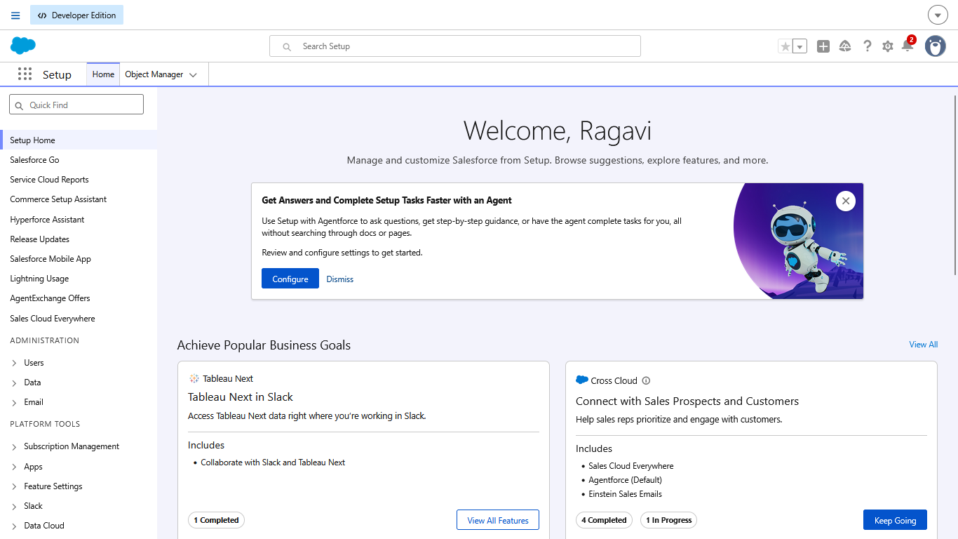

Milestone 2 – Player Profile Management

Objective
- The main objective of this milestone is to create a Player Profile Management module in Salesforce. It allows the cricket coach to maintain all important player details in one place and use them later for performance tracking, comparison, and team selection.
Activity 1 – Create Player Custom Object
First, create a custom object called Player in Salesforce.

Steps
- Log in to your Salesforce Developer account.
- Click the ⚙Gear Icon.
- Select Setup.
- Open Object Manager.
- Click Create → Custom Object.
- Enter the following details:
Field | Value

- Label | Player

- Plural Label | Players

- Record Name | Player Name

- Data Type | Text

- Allow Reports
- Allow Search
- Track Field History

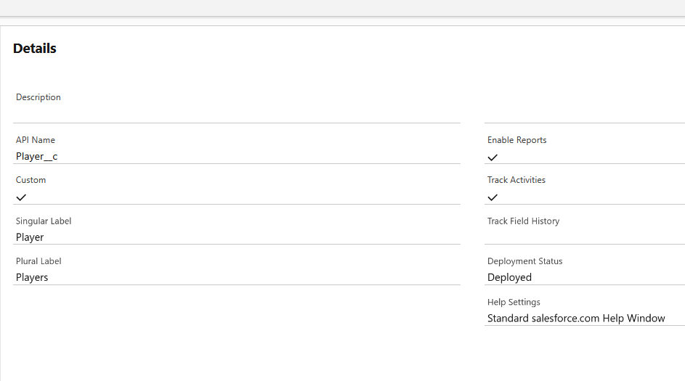
- Click Save.

Activity 2 – Create Player Profile Fields
After creating the Player object, create fields to store the player's profile information.
Go to:
Setup → Object Manager → Player → Fields & Relationships → New
Create the following fields:

PLAYER NUMBER:
- Data Type : Text
- Field Label: Player Number
- Field Name : Auto Populates
- Length : 3
- Click on Next → Next → Save and new.

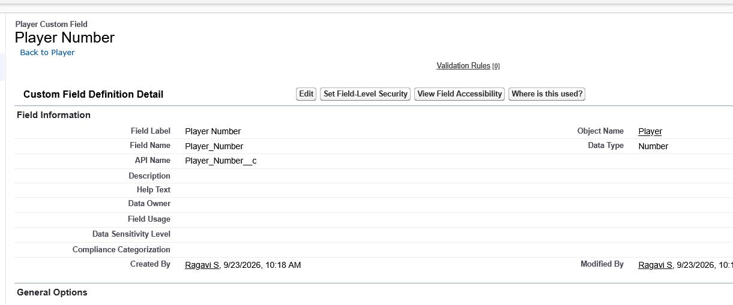

PROFILE PICTURE:
- Data Type : Text
- Field Label: PROFILE PICTURE
- Field Name : Auto Populates
- Length : 3

Click on Next → Next → Save and new

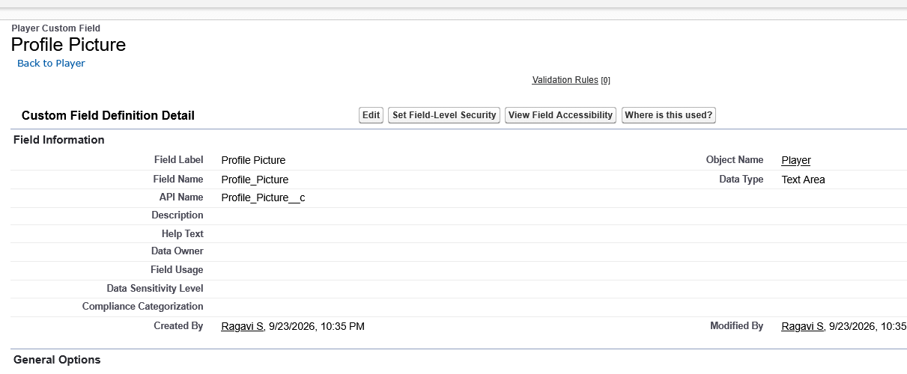

DATE OF BIRTH:
- Data Type : Date
- Field Label : Date of Birth
- Field Name : Auto Populates
- Click on Next → Next → Save and new.

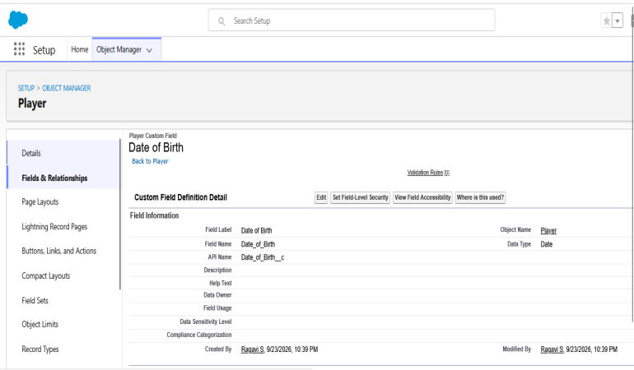

ROLE

- Data Type : Picklist
- Field Label : Role
- Field Name : Auto Populates
- Value : Enter value, with each value separated by a new line.
- Batsman
- Bowler
- Batsman & Wicket Keeper
- All Rounder

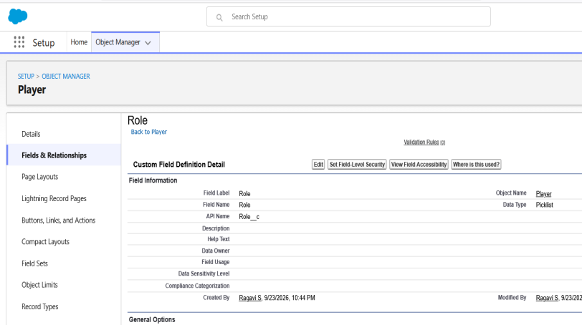

BATTING STYLE:
- Data Type : Picklist
- Field Label : Batting Style
- Field Name : Auto Populates
- Value : Enter value, with each value separated by a new line.
Right- Handed
Left - Handed
Click on Next → Next → Save and new.

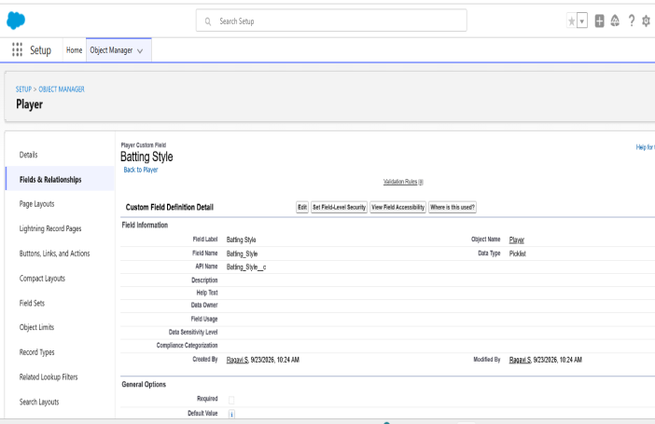

BOWLING STYLE:

- Data Type : Picklist
- Field Label : Bowling Style
- Field Name : Auto Populates
- Value : Enter value, with each value separated by a new line.
Right-Arm Fast
Left-Arm Fast
Right-Arm Medium
Left-Arm Medium
Right-Arm Spin
Left-Arm Spin
- Click on Next → Next → Save and new.

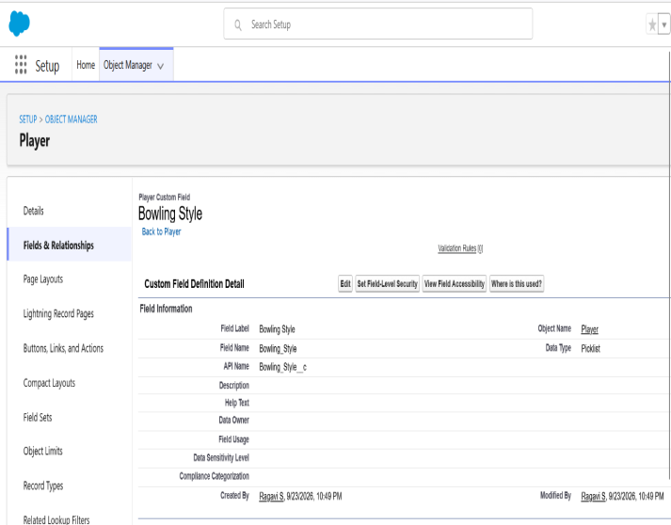

NATIONALITY:
Data Type : Picklist
Field Label : Nationality
Field Name : Auto Populates
Value : Enter value, with each value separated by a new line.
- Australia
- Bangladesh
- England
- India
- New Zealand
- Pakistan
- South Africa
- Sri Lanka
- West Indies
- Afghanistan
- Zimbabwe
- Ireland
- Scotland
- Netherlands
- United Arab Emirates
- Nepal
- United States of America
Click on Next → Next → Save and new.

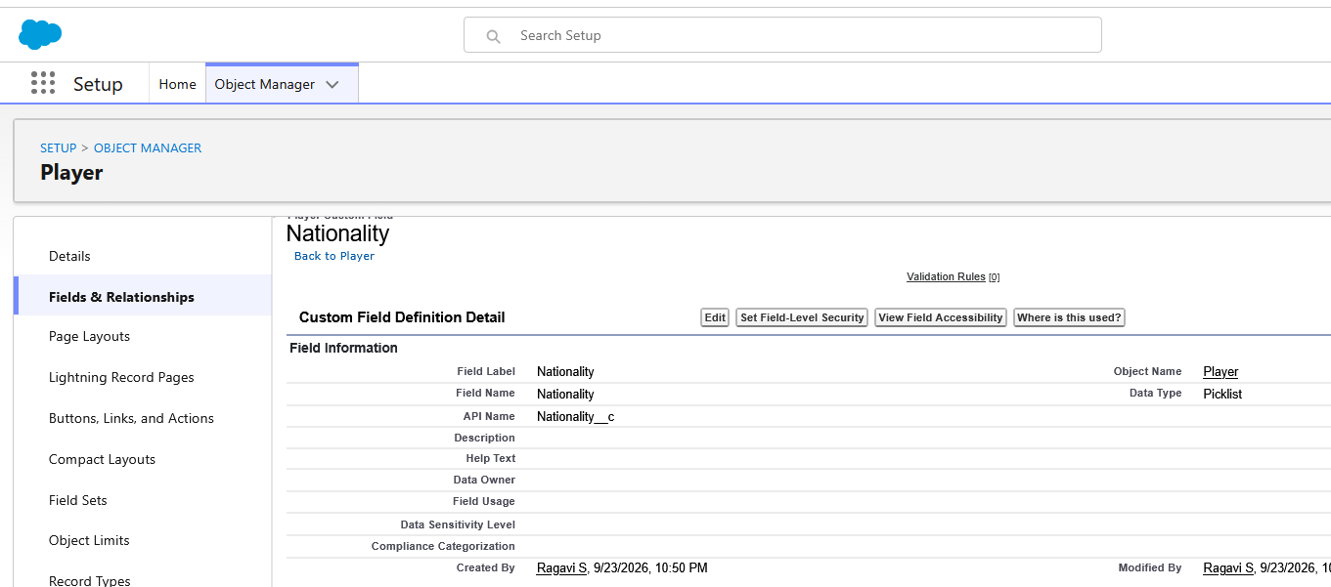

TEAM:
Data Type : Picklist
Field Label : Team
Field Name : Auto Populates
Value : Enter value, with each value separated by a new line

Chennai Super Kings (CSK)
Delhi Capitals (DC)
Kolkata Knight Riders (KKR)
Mumbai Indians (MI)
Punjab Kings (PBKS)
Rajasthan Royals (RR)
Royal Challengers Bangalore (RCB)
Sunrisers Hyderabad (SRH)
Gujarat Titans (GT)
Lucknow SuperGiants (LSG)

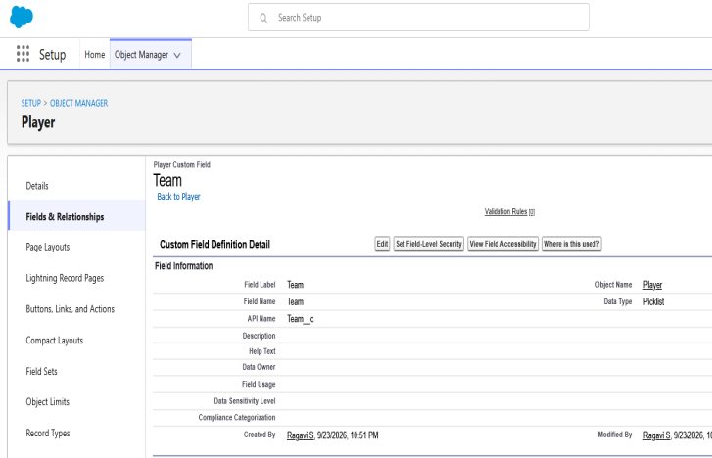

PLAYER STATUS:
Data Type : Picklist
Field Label : Player Status
Field Name : Auto Populates
Value : Enter value, with each value separated by a new line.

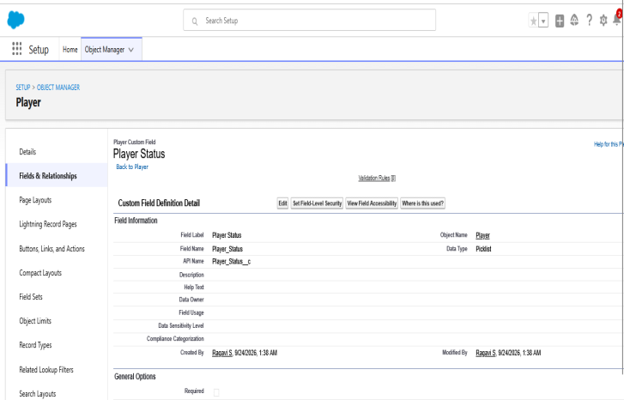

Milestone 3 – Match Performance Recording

Objective
- The main objective of this milestone is to record each player's performance after every match in Salesforce. The coach can enter batting, bowling, and fielding statistics in one place.
- This data will later be used for today's performance tracking, previous performance comparison, player analysis, reports, dashboards, and team selection.

Activity 1 – Create Match Performance Object
Create a custom object to store individual match performance details.
Steps:
- Go to Setup ⚙️
- Open Object Manager
- Click Create → Custom Object
- Enter:
- Label: Match Performance
- Plural Label: Match Performances
- Record Name: Match Performance Name
- Data Type: Text
- Enable:
- Allow Reports
- Allow Search
- Track Field History
- Click Save

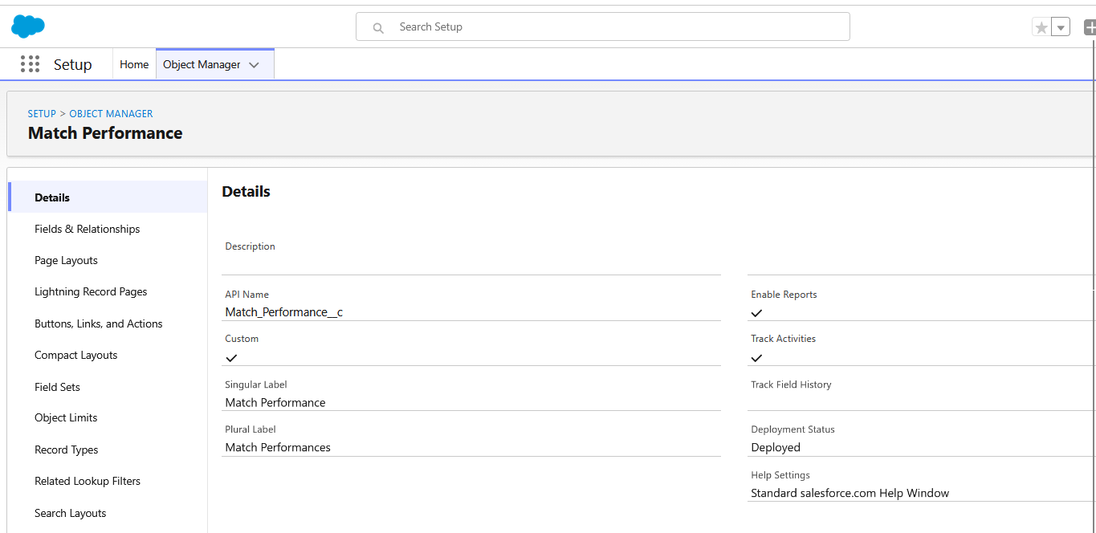

Activity 2 – Create Performance Fields
Go to:
Object Manager → Match Performance → Fields & Relationships → New
Create the following fields:

MATCH DATE:
- Data Type : Number
- Field Label: Runs Scored
- Field Name : Auto Populates
- Click on Next → Next → Save and new.

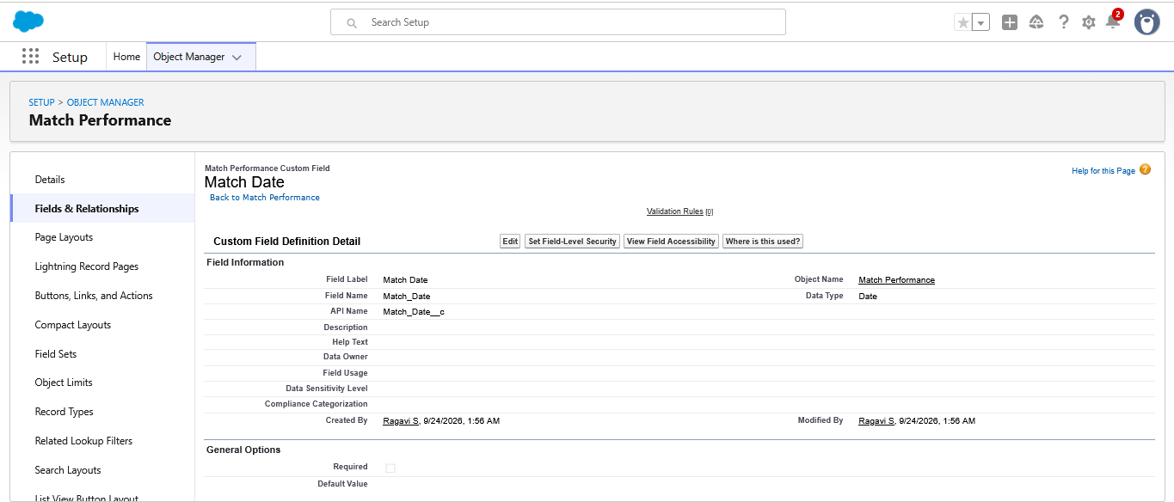

MATCH TYPE
- Data Type : Picklist
- Field Label: Match Result
- Field Name : Auto Populates
- Value : Enter value, with each value separated by a new line
WON
LOST
DRAW
- Click on Next → Next → Save and new.

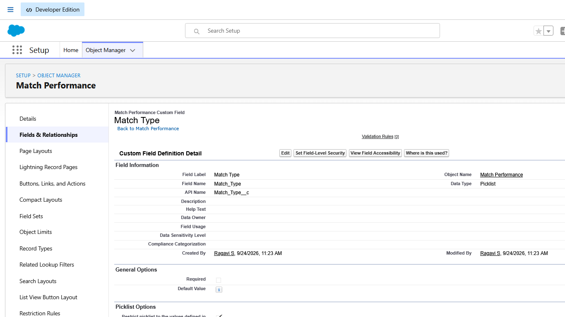

RUNS SCORED

- Data Type : Number
- Field Label: Runs Scored
- Field Name : Auto Populates
- Click on Next → Next → Save and new.

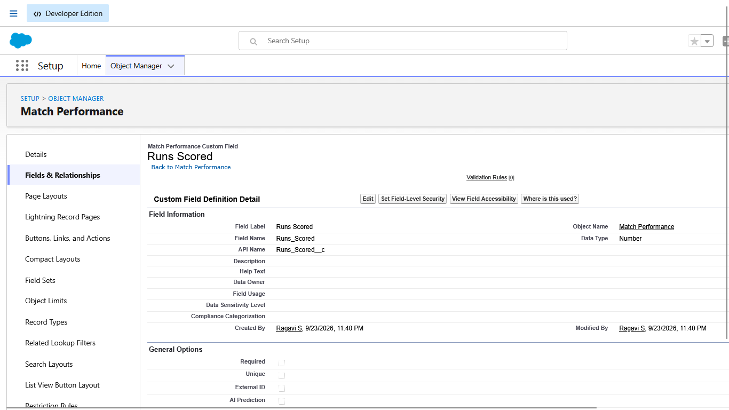

BALLS FACED
- Data Type : Number
- Field Label: Balls Faced
- Field Name : Auto Populates
- Click on Next → Next → Save and new.

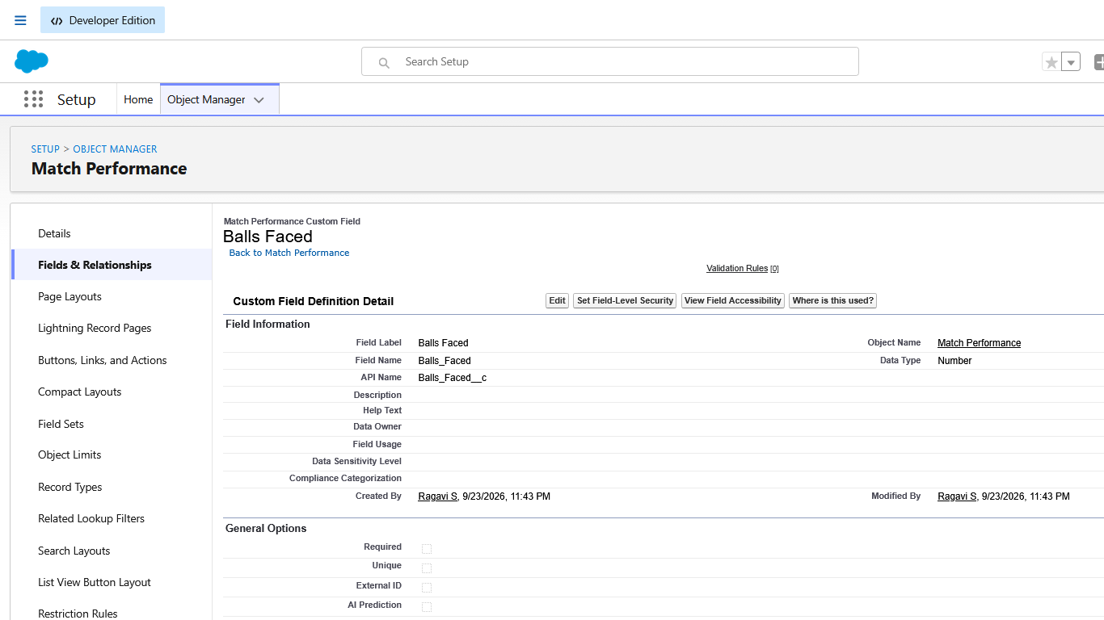
FOURS
- Data Type : Number
- Field Label: Fours
- Field Name : Auto Populates
- Click on Next → Next → Save and new.

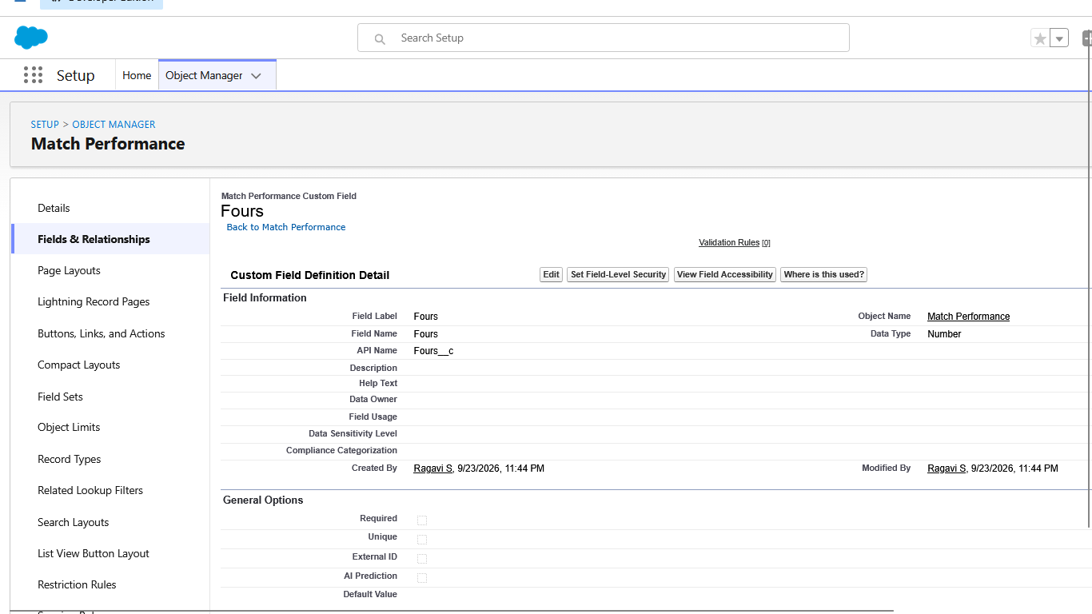

SIXES

- Data Type : Number
- Field Label: Sixes
- Field Name : Auto Populates
- Click on Next → Next → Save and new.

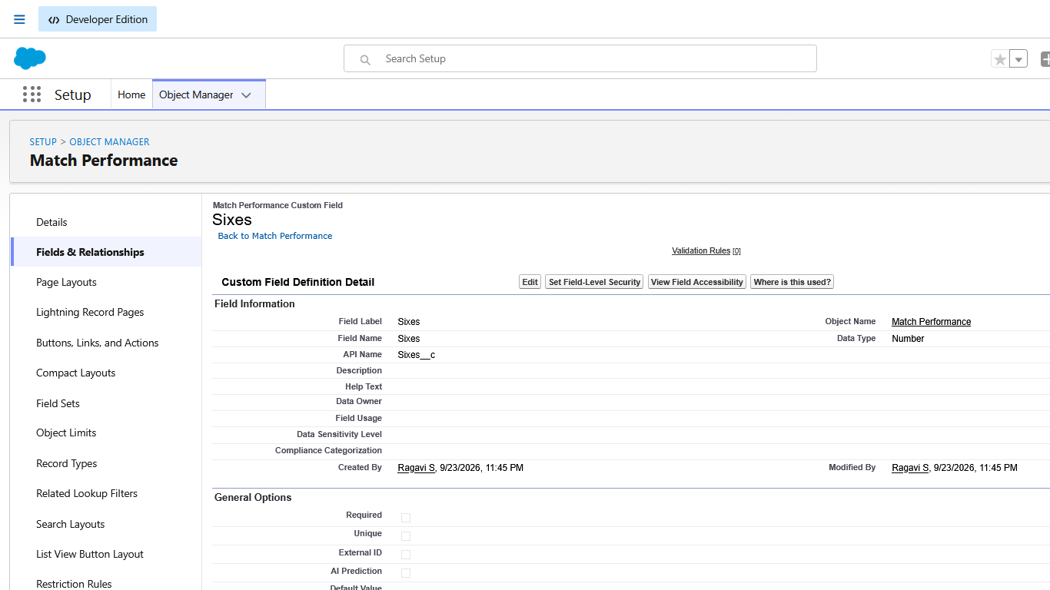

OVERS BOWLED

- Data Type : Number
- Field Label: Overs Bowled
- Field Name : Auto Populates
- Click on Next → Next → Save and new.

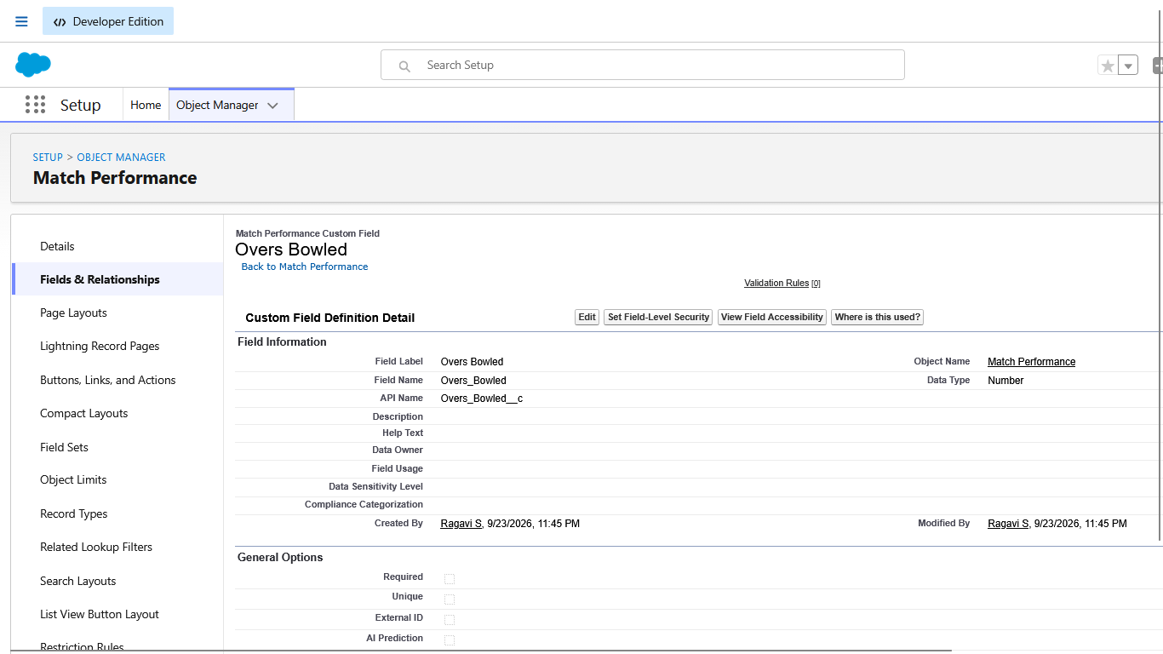

WICKETS TAKEN
- Data Type : Number
- Field Label: Wickets Taken
- Field Name : Auto Populates
- Click on Next → Next → Save and new.

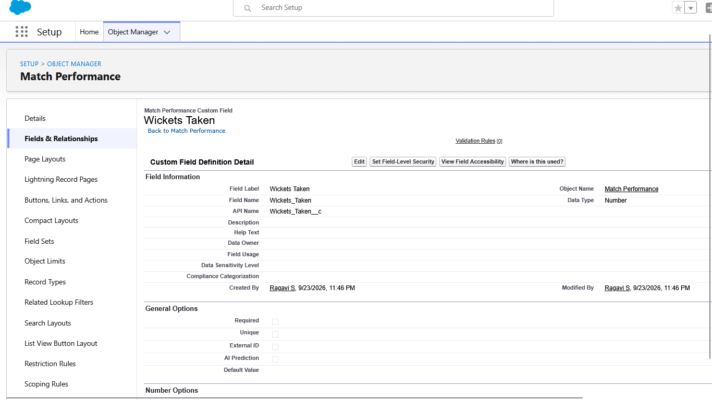

RUNS CONCEDED

- Data Type : Number
- Field Label: Runs Conceded
- Field Name : Auto Populates
- Click on Next → Next → Save and new.

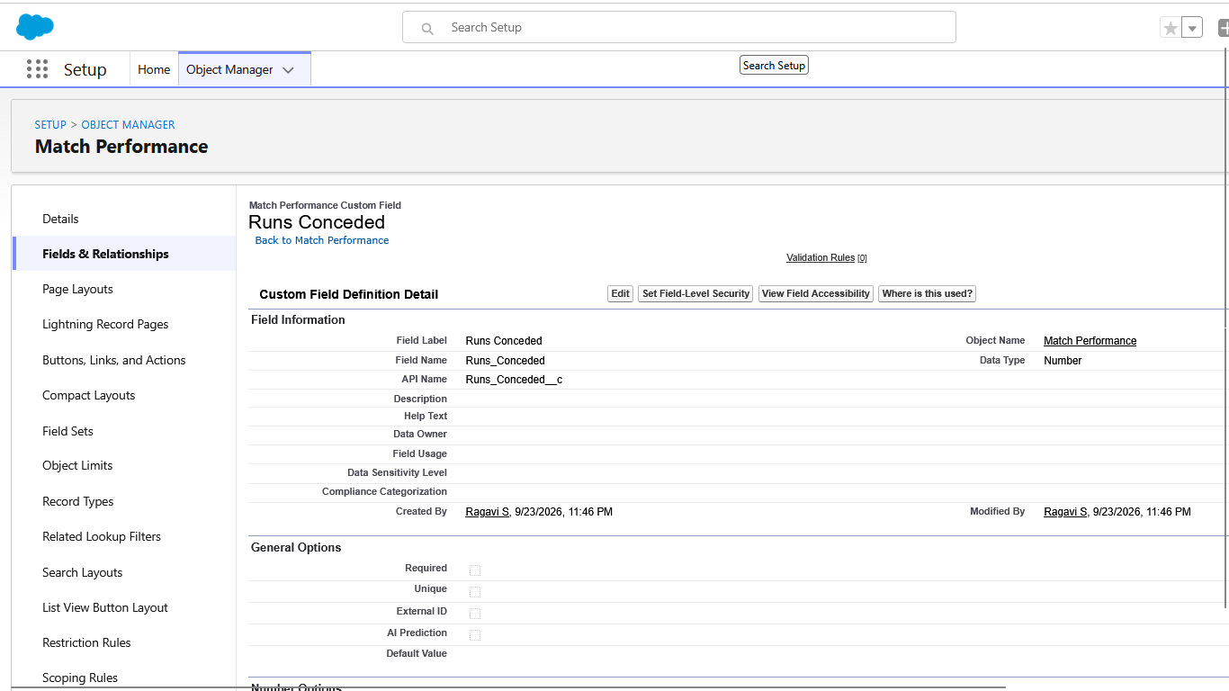

MAIDEN OVERS

- Data Type : Number
- Field Label: Maiden Overs
- Field Name : Auto Populates
- Click on Next → Next → Save and new.

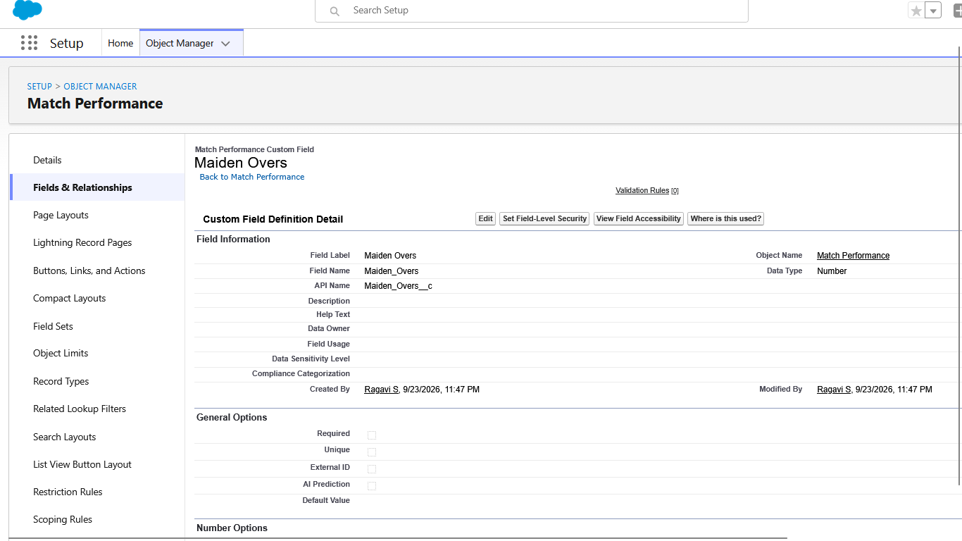
CATCHES

- Data Type : Number
- Field Label: Catches
- Field Name : Auto Populates
- Click on Next → Next → Save and new.

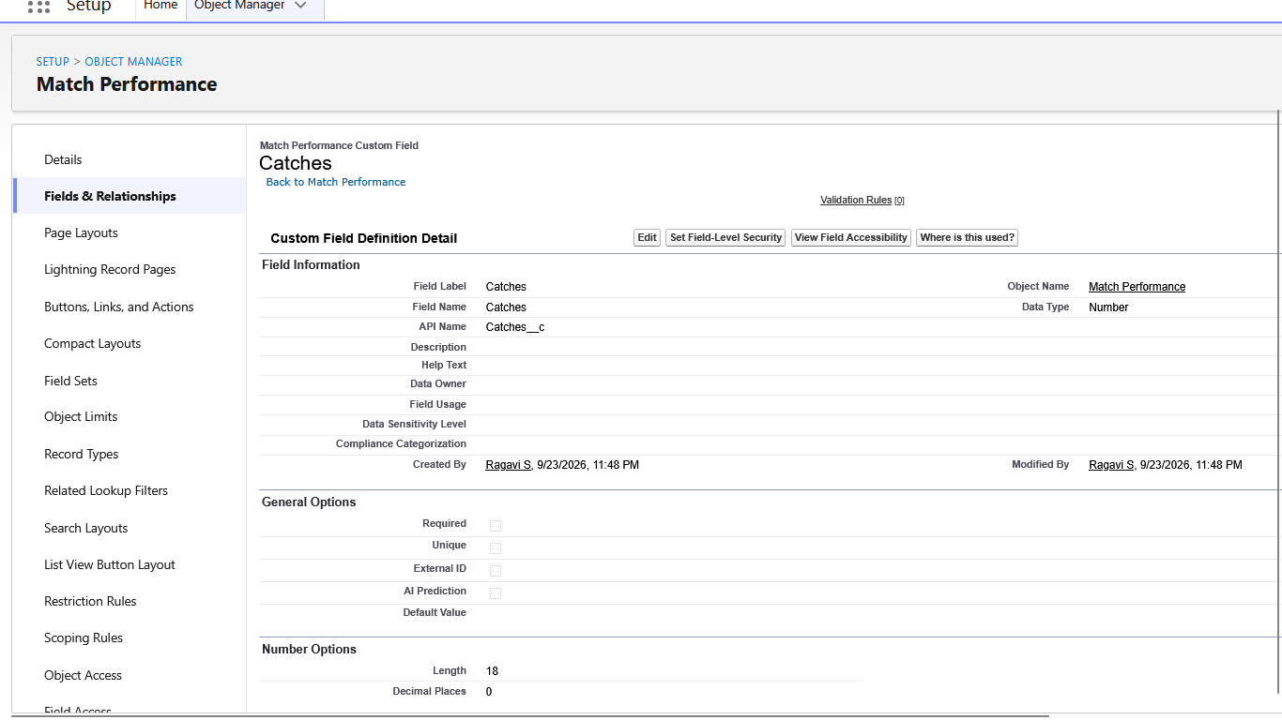

STUMPINGS
- Data Type : Number
- Field Label: Stumpings
- Field Name : Auto Populates
- Click on Next → Next → Save and new

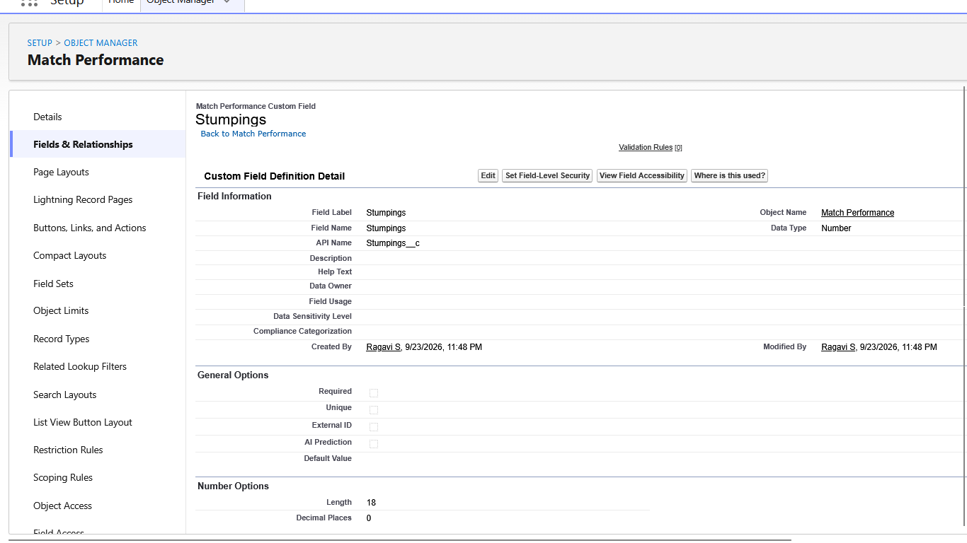

PLAYER OF THE MATCH

- Data Type : Checkbox
- Field Label: Player of the Match
- Field Name : Auto Populates
- Click on Next → Next → Save and new.

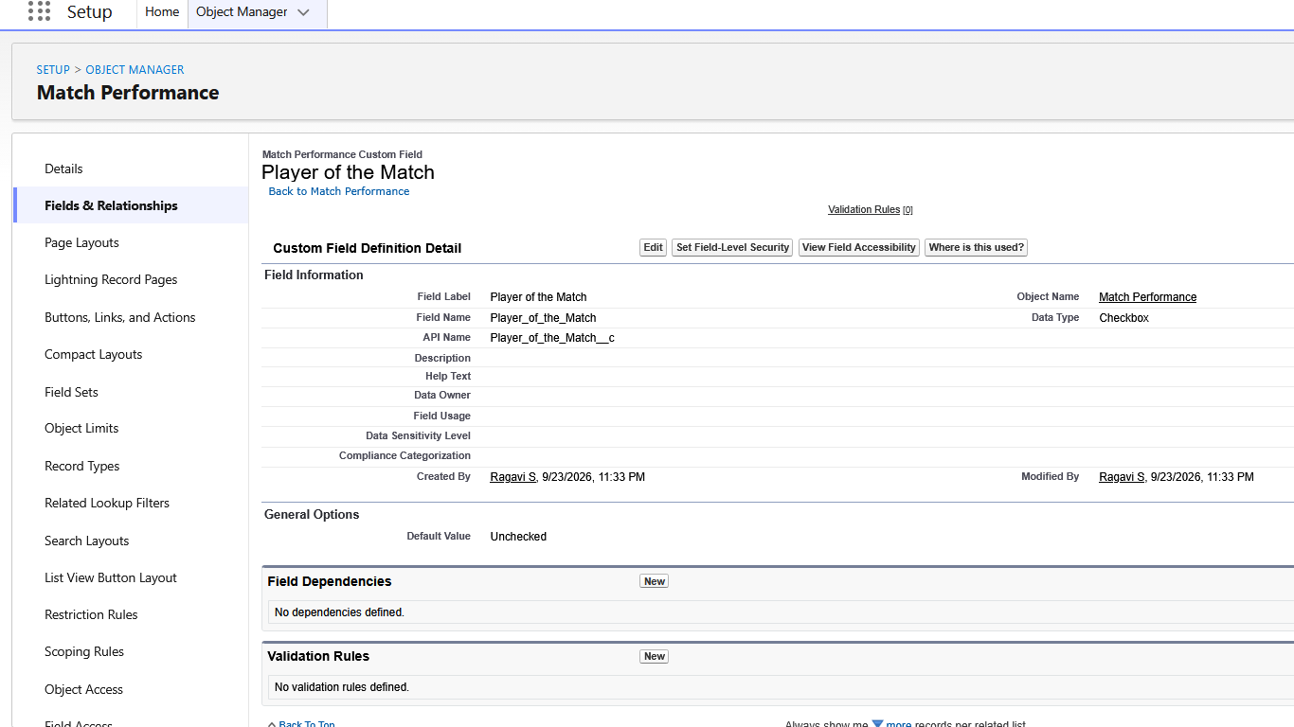

MATCH RESULT

- Data Type : Picklist
- Field Label: Match Result
- Field Name : Auto Populates
- Value : Enter value, with each value separated by a new line
WON
LOST
DRAW
- Click on Next → Next → Save and new.

Activity 3 – Enter Player Match Performance

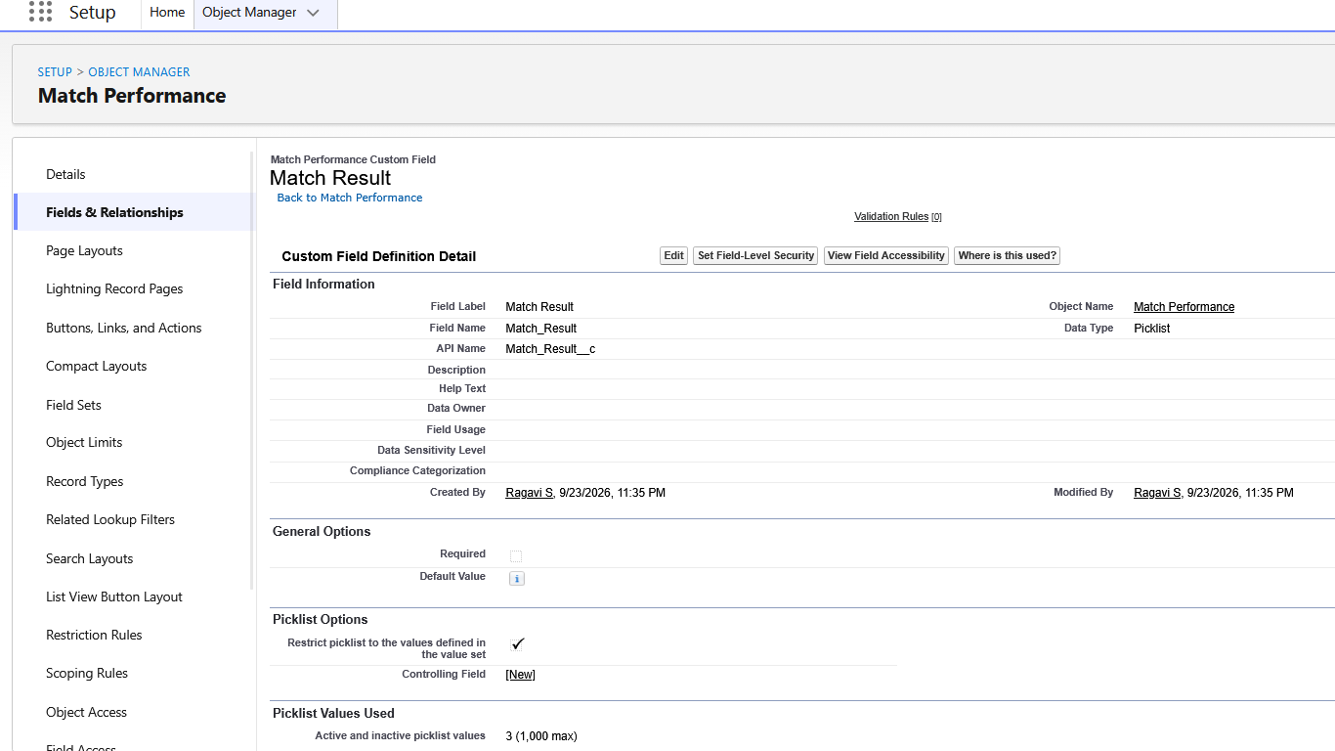

Activity to enter Player Name

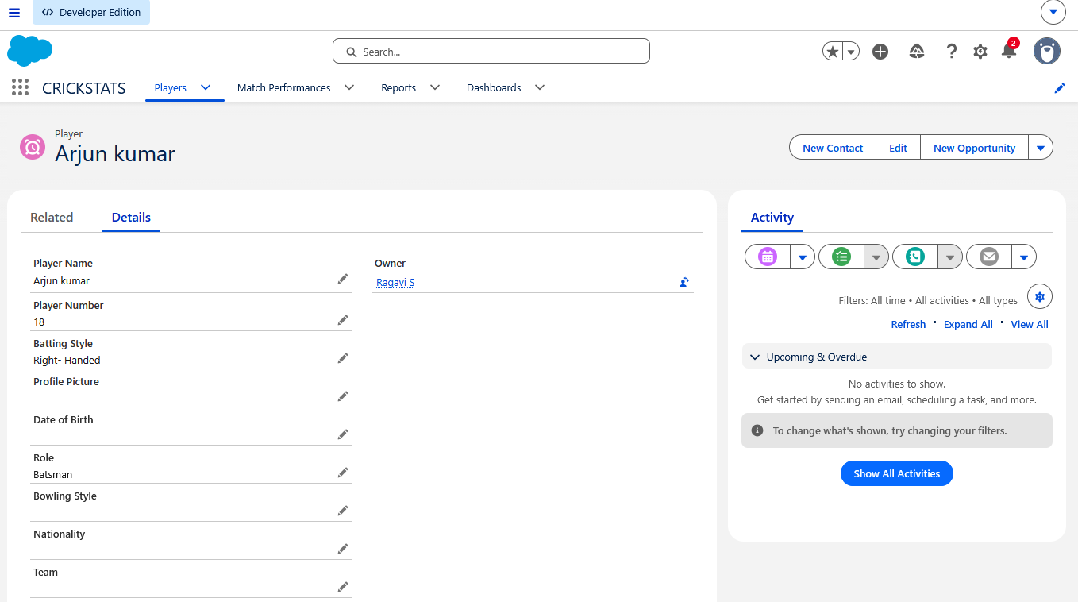

Milestone 4 – Player–Performance Relationship

Objective
- The main objective of this milestone is to connect the Player object with the Match Performance object in Salesforce.
- In CRICKSTATS, a player can participate in many matches. Therefore, all the performance records of a player should be connected to that player's profile. This helps the coach view the complete performance history of a player from one place.

Activity 1 – Create Player–Performance Relationship
First, create a relationship between Player and Match Performance.
Steps:
- Go to Setup ⚙
- Select Object Manager
- Open Match Performance
- Select Fields & Relationships
- Click New
- Select Master-Detail Relationship
- Click Next
- In Related To, select Player
- Click Next
- Enter:
- Field Label: Player
- Click Next → Next → Save
Now, the Match Performance object will have a Player field.
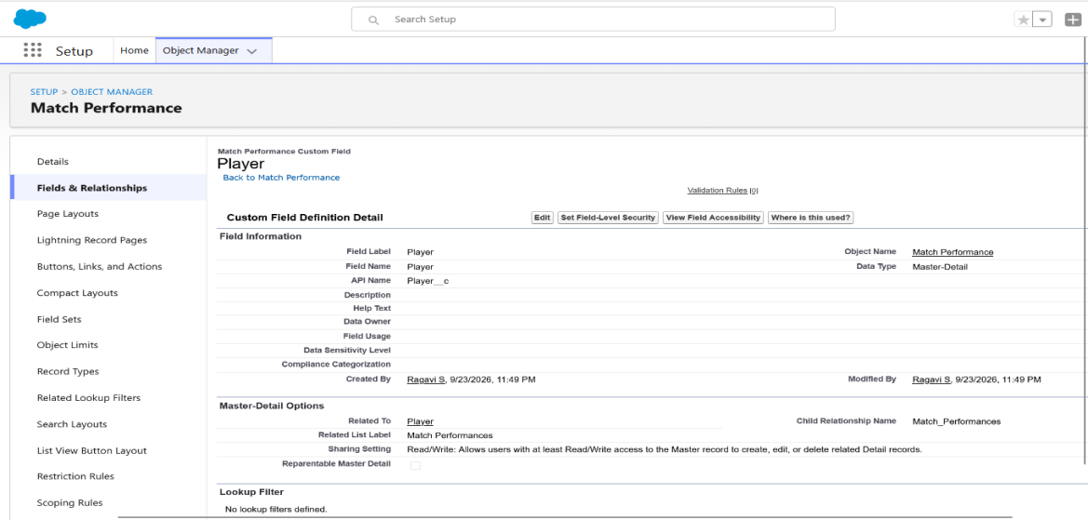

Relationship Structure
Player
│
├── Match Performance 1
├── Match Performance 2
├── Match Performance 3
└── Match Performance 4
Here:
- Player = Parent
- Match Performance = Child
- One Player can have many Match Performance records.
- Each Match Performance record belongs to one Player.

Activity 2 – Link Performance Records with Player
After creating the relationship, open:
App Launcher → CRICKSTATS → Match Performances → New
Now the Player field will be available.
For example:
- Match Performance Name: Arjun – Match 01
- Player Name: Arjun Kumar
- Match Date: 24/09/2026
- Match Type: T20
- Runs Scored: 65
- Balls Faced: 42
- Fours: 6
- Sixes: 2
- Overs Bowled: 0
- Wickets Taken: 0
- Runs Conceded: 0
- Maiden Overs: 0
- Catches: 1
- Stumpings: 0
- Player of the Match: No
- Match Result: Won
Click Save.
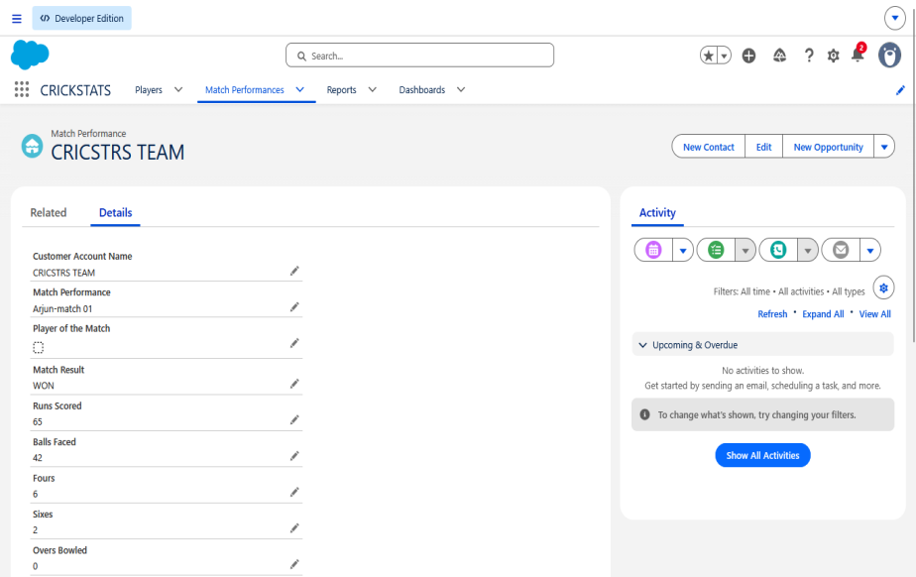
Select Arjun Kumar in the Player field and click Save.
The performance is now connected to Arjun Kumar's profile.

Activity 3 – Verify Player Performance History
The purpose of this activity is to verify that the Match Performance records are correctly connected to the selected Player.

Steps
- Open App Launcher → CRICKSTATS.
- Select Players.
- Open a player record, for example Arjun Kumar.
- Click the Related tab.
- Find the Match Performances related list.
- Check whether the previously created performance records are displayed.

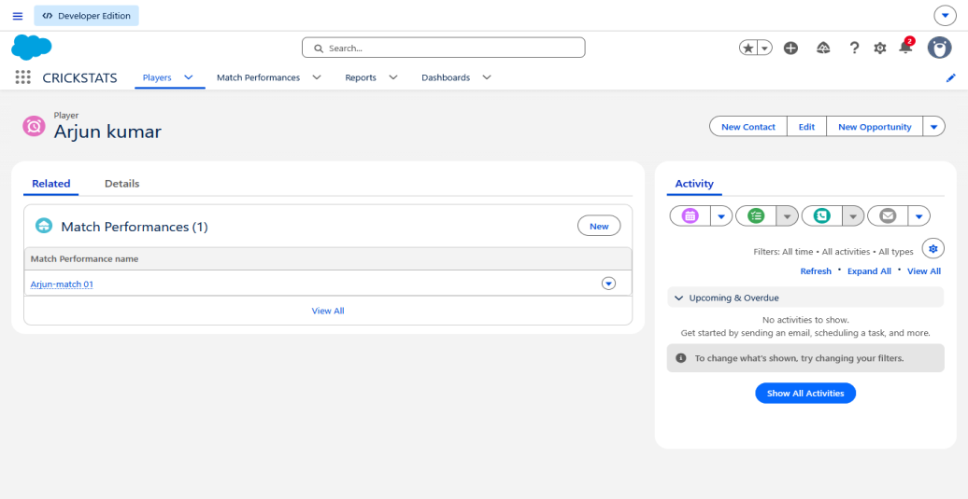
If these records appear under Arjun Kumar, the Player–Performance relationship is working correctly.

Explanation
This activity confirms that a player's profile can display all their related match performances in one place. It helps the coach review the player's previous performance history and provides the foundation for performance comparison and automatic statistics.

Activity 4 – Verify Multiple Player Performances
The purpose of this activity is to verify that multiple Match Performance records can be linked to the same Player.

Steps
- Open App Launcher → CRICKSTATS.
- Go to Match Performances.
- Click New.
- Create another performance for the same player.
Example:
- Enter the following details:
- Match Performance Name: Kavin – Match 02
- Player: Kavin Raj
- Match Date: 25/09/2026
- Match Type: ODI
- Runs Scored: 58
- Balls Faced: 71
- Fours: 5
- Sixes: 1
- Overs Bowled: 2
- Wickets Taken: 1
- Catches: 2
- Match Result: Won
- Click Save.
- Go to Players → Kavin Raj.
- Open the Related tab.
- Check the Match Performances section.
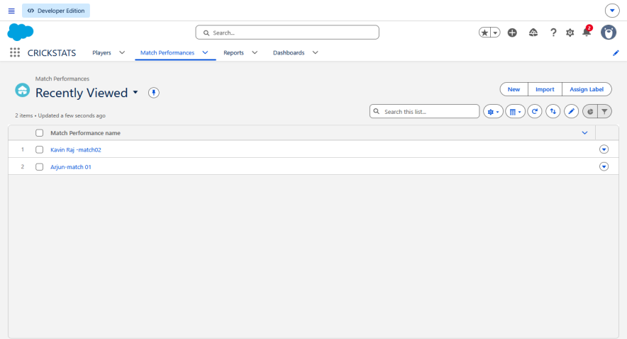
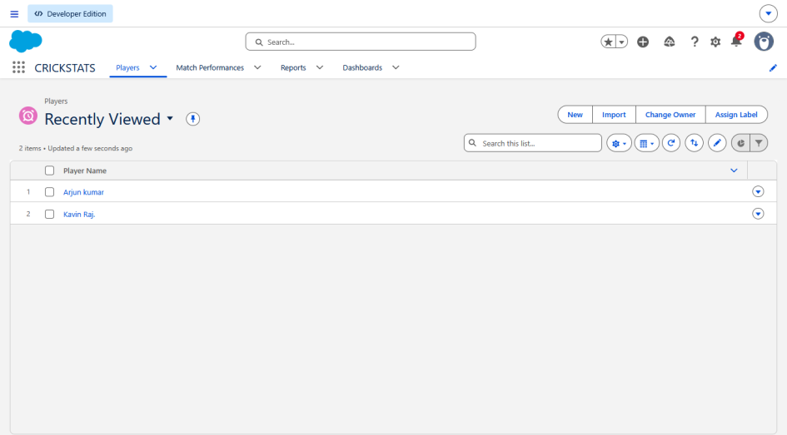
The newly created performance record should be displayed along with the player's other match records. This confirms that multiple performance records can be connected to the same player.
Milestone 5 – Automated Performance Summary

Objective
- The main objective of this milestone is to automatically calculate and display a player's overall performance statistics using the Match Performance records.
- Instead of the coach manually calculating the total runs, wickets, fours, sixes, and matches played, Salesforce will calculate these values automatically. This helps the coach quickly understand a player's overall performance.

Activity 1 – Create Roll-Up Summary Fields
- Since the Player → Match Performance relationship has been created using Master-Detail, Salesforce can calculate values from the related Match Performance records.
Go to:
Setup → Object Manager → Player → Fields & Relationships → New
Select:
Roll-Up Summary → Next
Create the following fields one by one.

1. Matches Played
- Field Label: Matches Played
- Summarized Object: Match Performances
- Roll-Up Type: COUNT
- Click Next → Next → Save
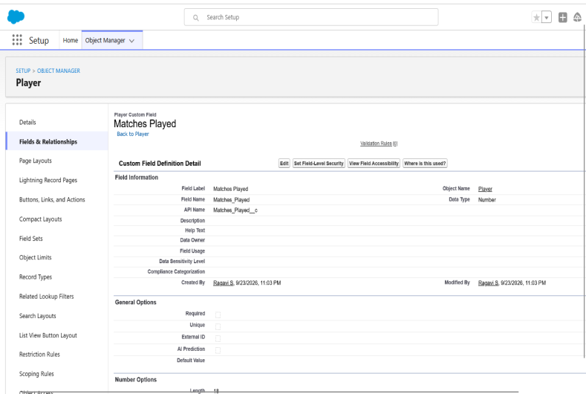
This automatically counts the number of Match Performance records connected to the player.

2. Total Runs
Create another Roll-Up Summary field:
- Field Label: Total Runs
- Summarized Object: Match Performances
- Roll-Up Type: SUM
- Field to Aggregate: Runs Scored
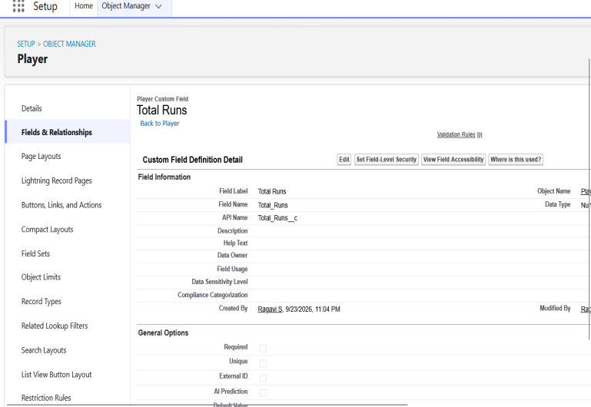
This calculates the total runs scored by the player across all recorded matches.

3. Total Fours
- Field Label: Total Fours
- Summarized Object: Match Performances
- Roll-Up Type: SUM
- Field to Aggregate: Fours
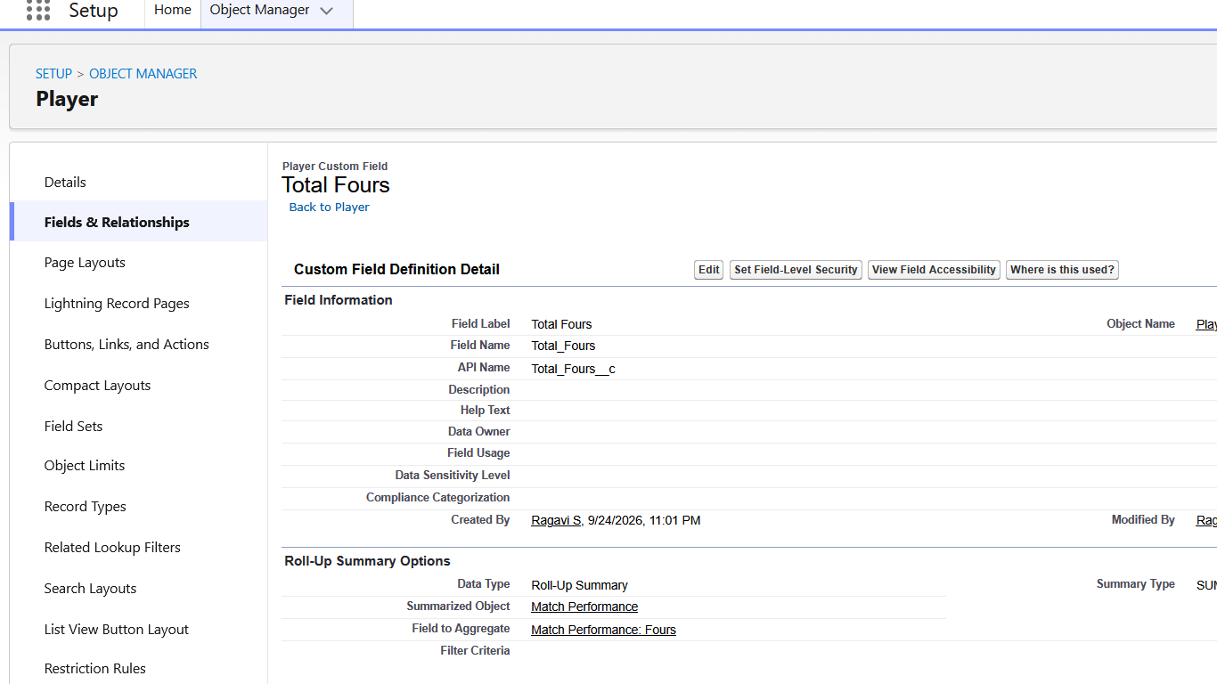

4. Total Sixes
- Field Label: Total Sixes
- Summarized Object: Match Performances
- Roll-Up Type: SUM
- Field to Aggregate: Sixes
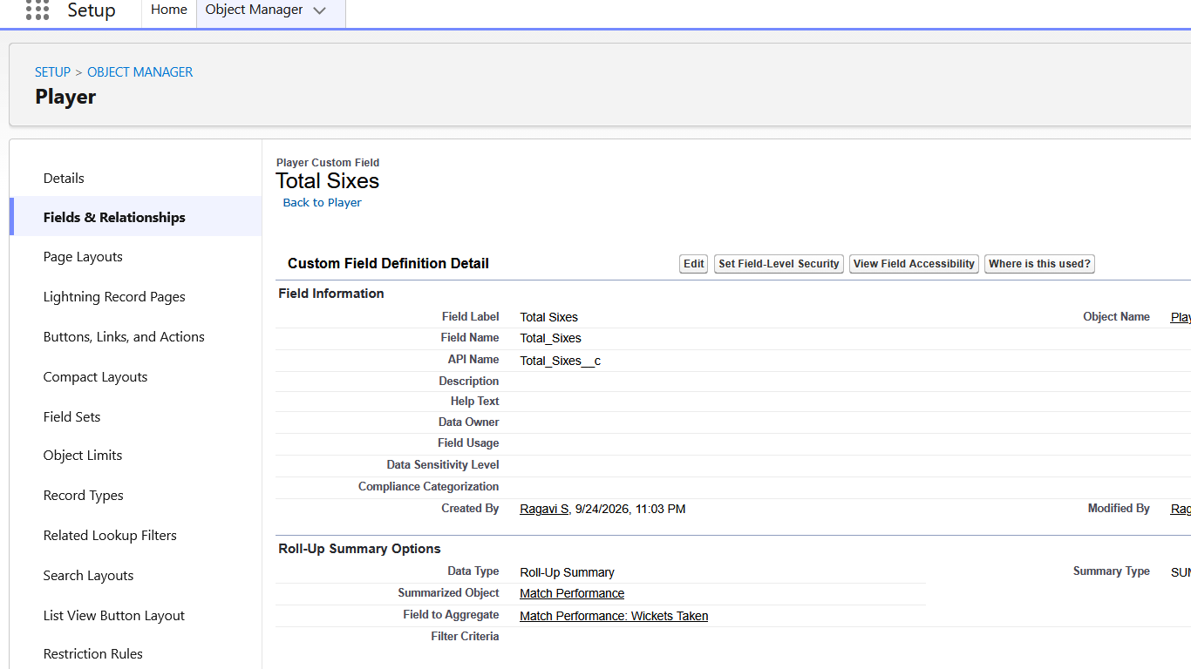

5. Total Wickets
- Field Label: Total Wickets
- Summarized Object: Match Performances
- Roll-Up Type: SUM
- Field to Aggregate: Wickets Taken
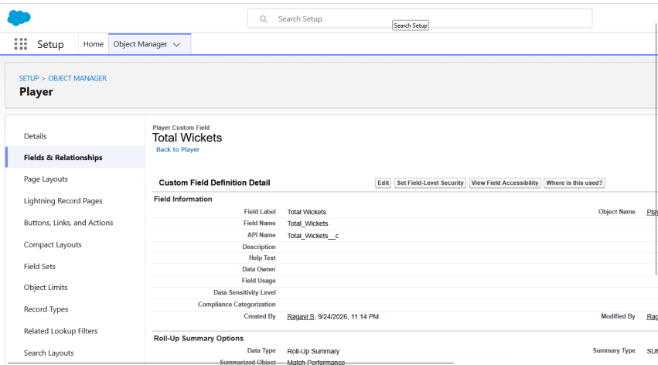

6. Total Catches
- Field Label: Total Catches
- Summarized Object: Match Performances
- Roll-Up Type: SUM
- Field to Aggregate: Catches
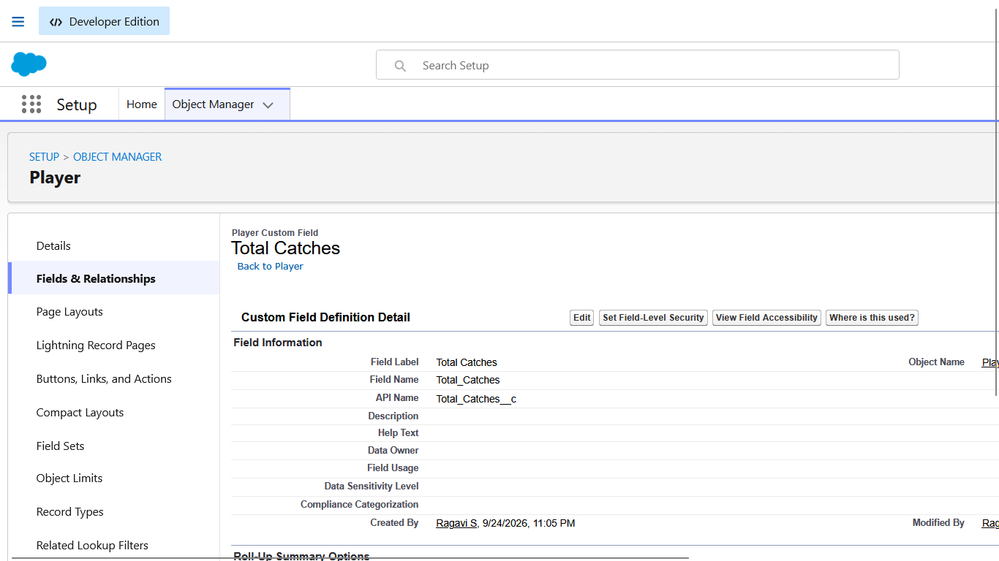

Activity 2 – Create Average Runs Formula
Now create a formula field to calculate the player's average runs per match.
Go to:
Player → Fields & Relationships → New → Formula
Enter:
- Field Label: Average Runs
- Return Type: Number
- Decimal Places: 2
Formula:
IF(
Matches_Played__c > 0,
Total_Runs__c / Matches_Played__c,
0
)

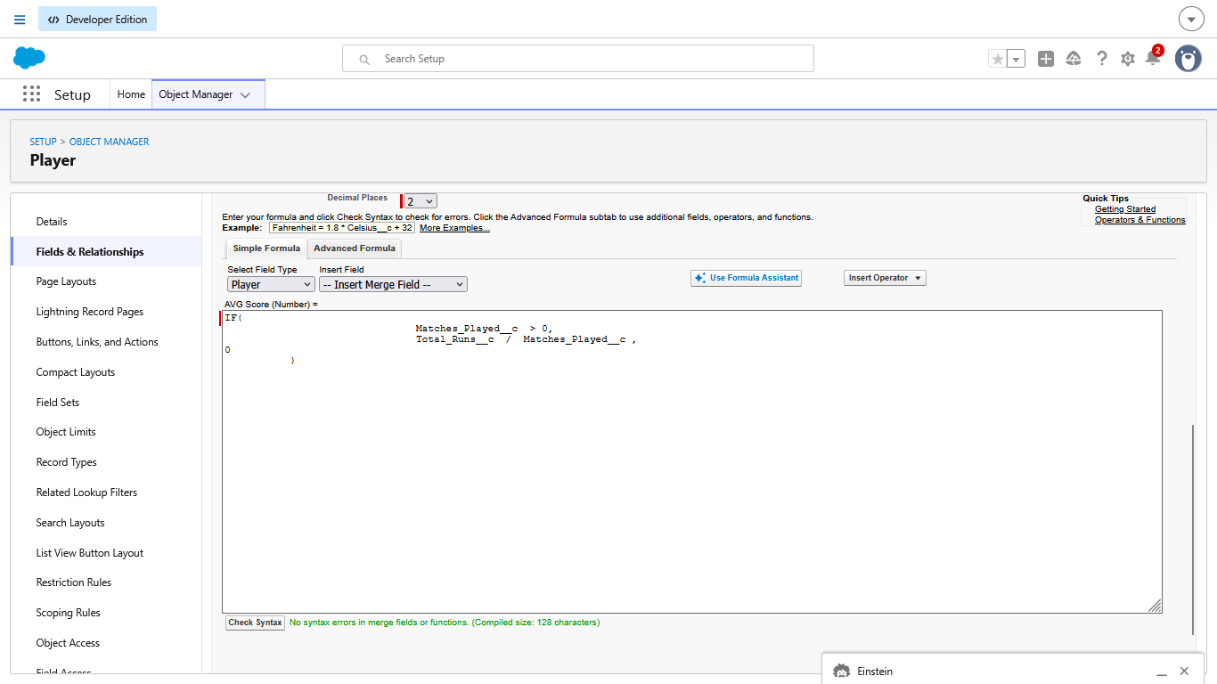
If your field API names are different, use Insert Field in Salesforce instead of manually typing the API names.
This calculates the average runs based on the total runs and number of matches.
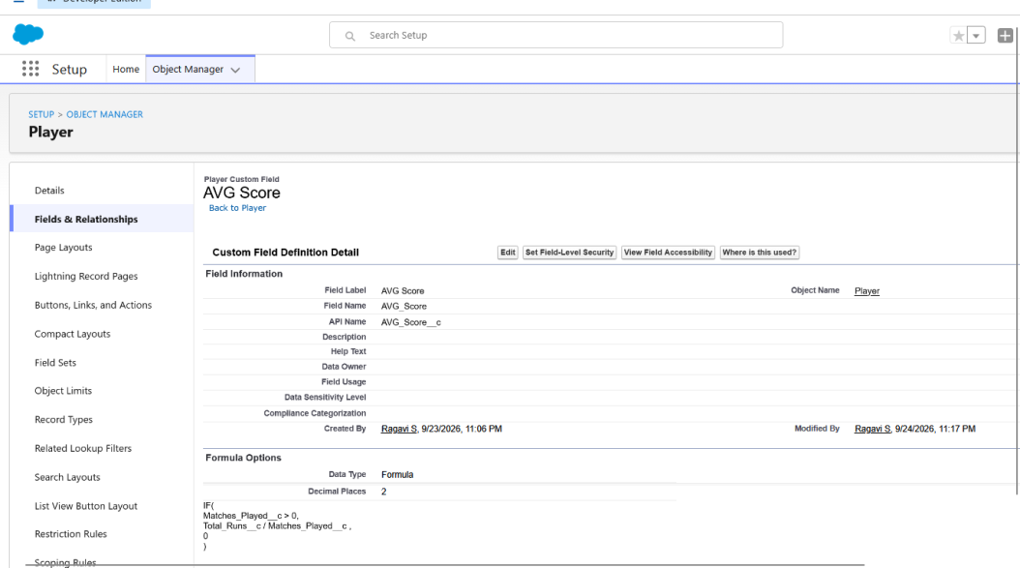

Activity 3 – Verify Automated Statistics
Now test whether Salesforce is calculating the statistics correctly.
Go to:
App Launcher → CRICKSTATS → Players → Arjun Kumar
Open the Details tab.

You should see fields such as:
- Matches Played
- Total Runs
- Total Fours
- Total Sixes
- Total Wickets
- Total Catches
- Average Runs
For example, if Arjun Kumar has two performance records with 65 runs and 42 runs, Salesforce automatically calculates
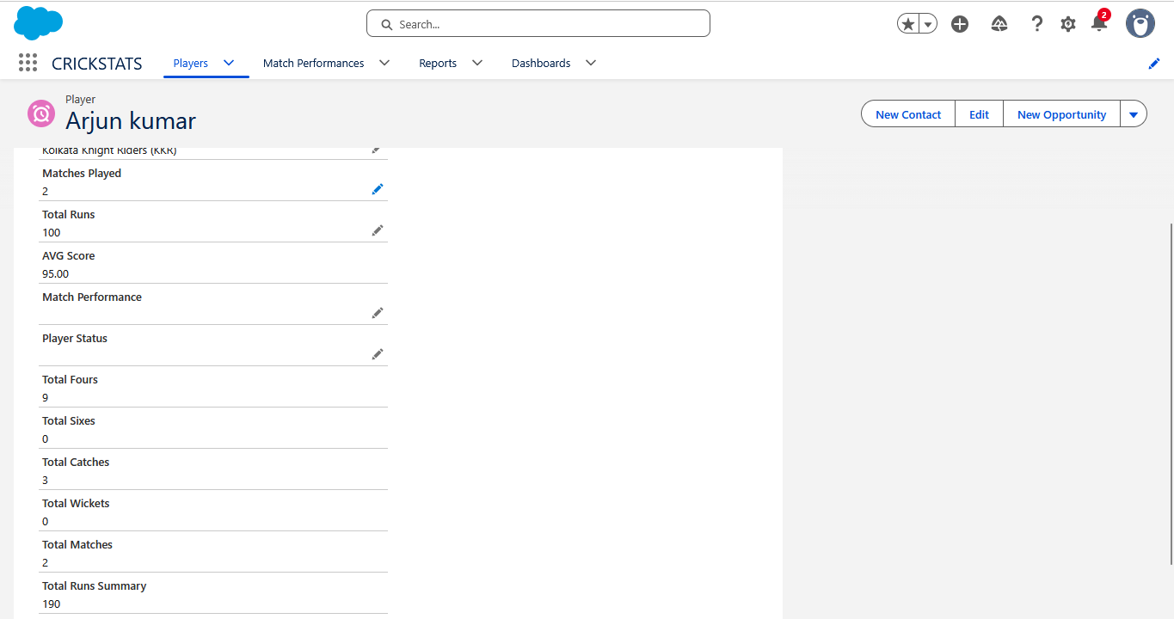
Ex:
Matches Played = 2
Total Runs = 195
Average Runs = 95.00
If another Match Performance is added, these values automatically update.

Activity 4 – Test Automatic Update
Create one more Match Performance for the same player.
For example:
Player: mahendra sign dhoni
Runs Scored: 17,288
Fours: 36
Sixes: 34
Wickets Taken: 300
Save the record.
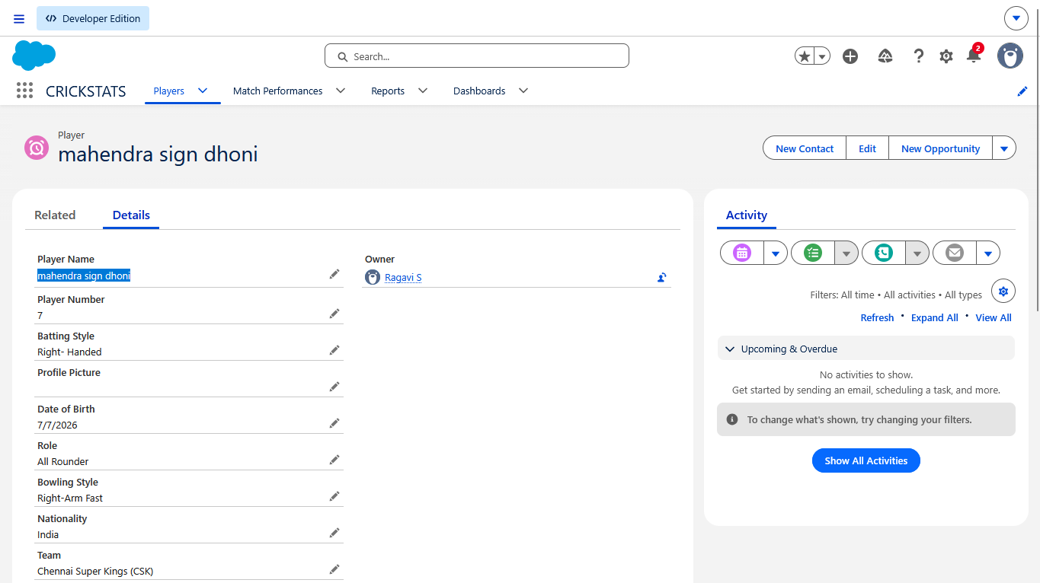
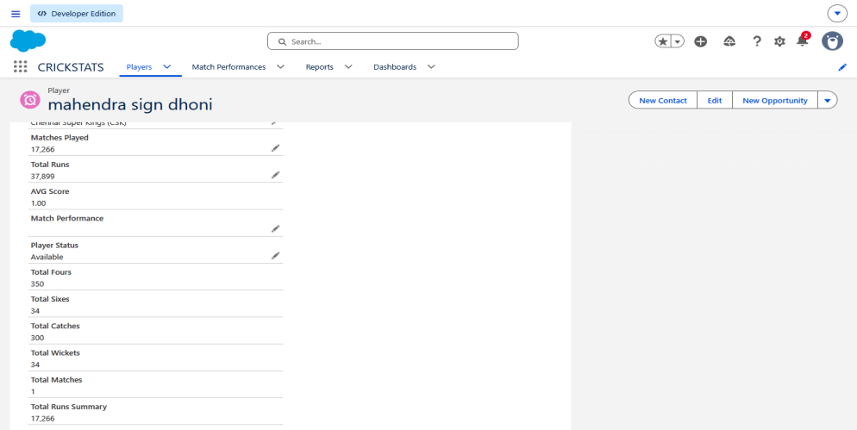
Now return to:
Players → Arjun Kumar → Details
The statistics should automatically update.
This confirms that the performance summary is dynamic and does not require manual calculation.

Milestone 6 – Today’s Performance Tracking

Objective
- The objective of this milestone is to create a Salesforce report that allows the Cricket Coach to view the performance of players for the current day. The report displays important batting, bowling, and fielding statistics in one place. This helps the coach quickly check today’s performance and use it for further comparison and planning.

Activity 1 – Create Today’s Performance Report
- Open the CRICKSTATS application in Salesforce.
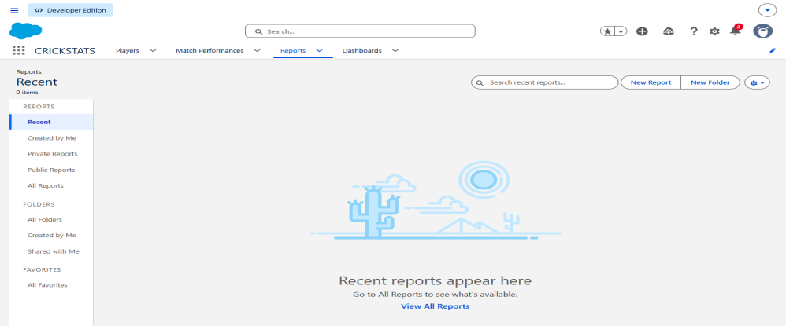
- Click Reports from the navigation bar.
- Click New Report.
- Search for Match Performances.
- Select Match Performances.
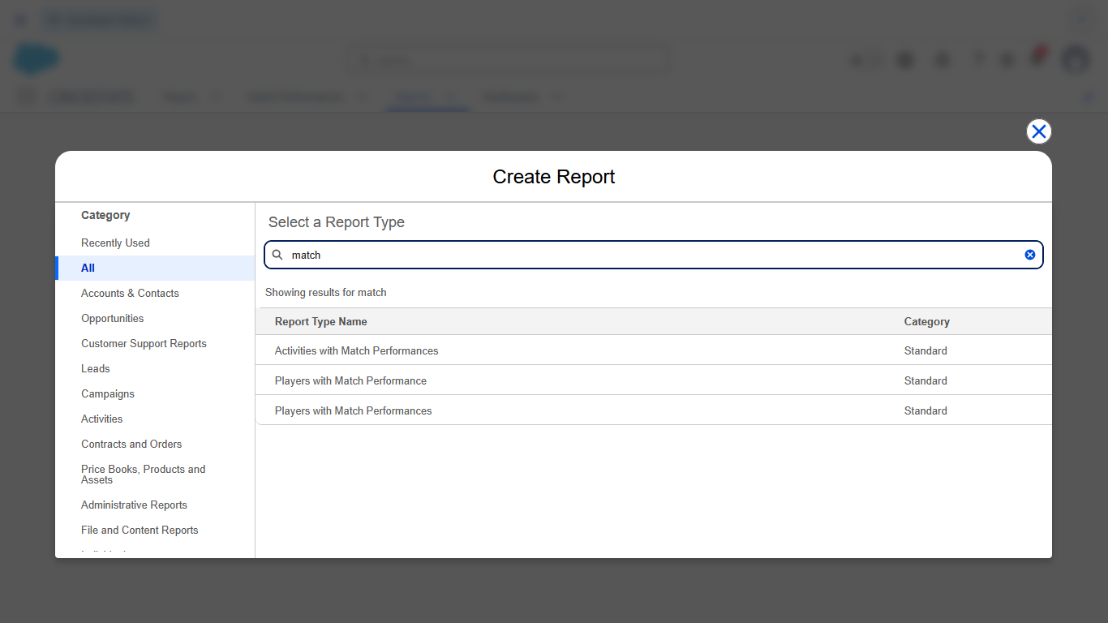
- Click Start Report.
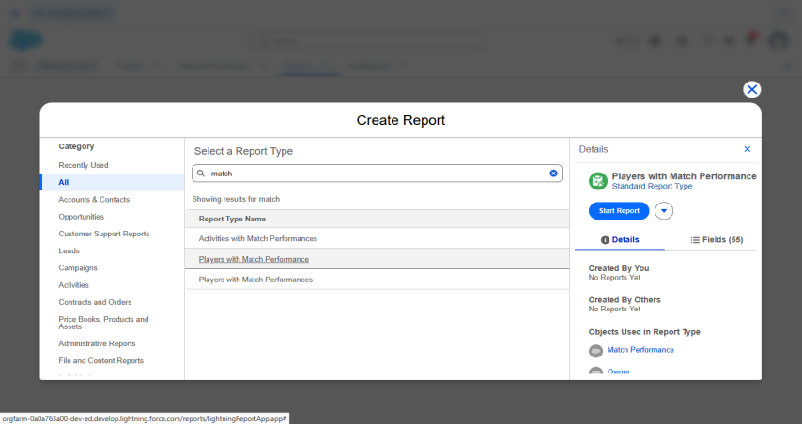

The Salesforce Report Builder will open.
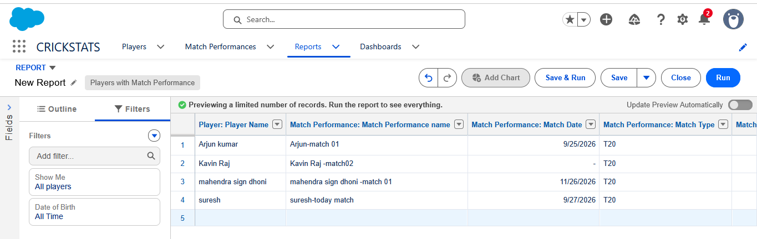

Activity 2 – Add Performance Fields
In the Outline → Columns section, add the following fields:
- Player
- Match Date
- Match Type
- Runs Scored
- Balls Faced
- Fours
- Sixes
- Overs Bowled
- Wickets Taken
- Catches
- Match Result
These fields provide a complete view of the player's performance for the selected match.
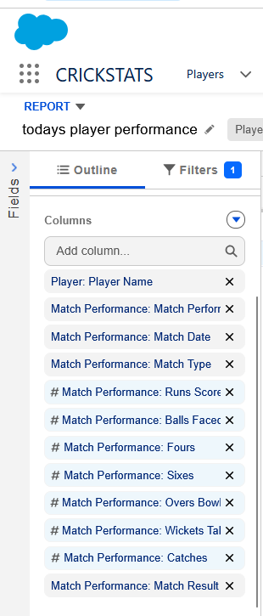

Activity 3 – Apply Today’s Date Filter
To display only the current day's performance:
- Go to the Filters section.
- Select Match Date.
- Set the date filter to TODAY.
- Click Apply.
The report will now display only the Match Performance records entered for the current date.
For example, if the current date is 27/09/2026, only records with Match Date 27/09/2026 will be displayed.
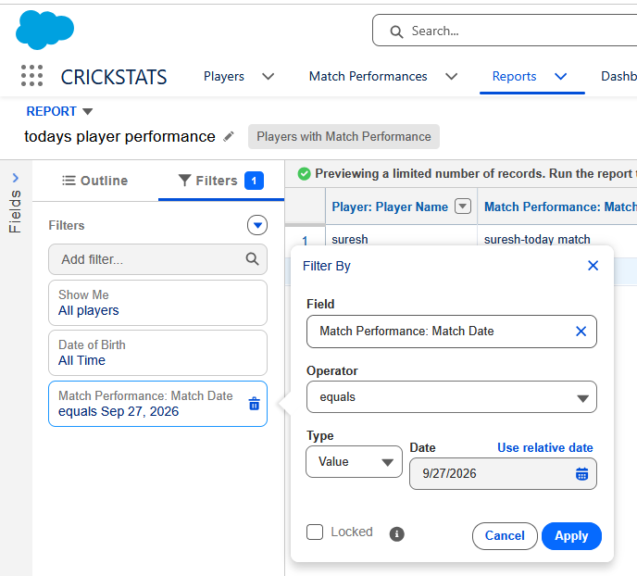

Run and Verify the Report
Click Run.
The report should display the players and their current-day statistics, such as:
- Player Name
- Runs Scored
- Fours
- Sixes
- Wickets Taken
- Catches
- Match Result
The coach can use this report to quickly identify how players performed today

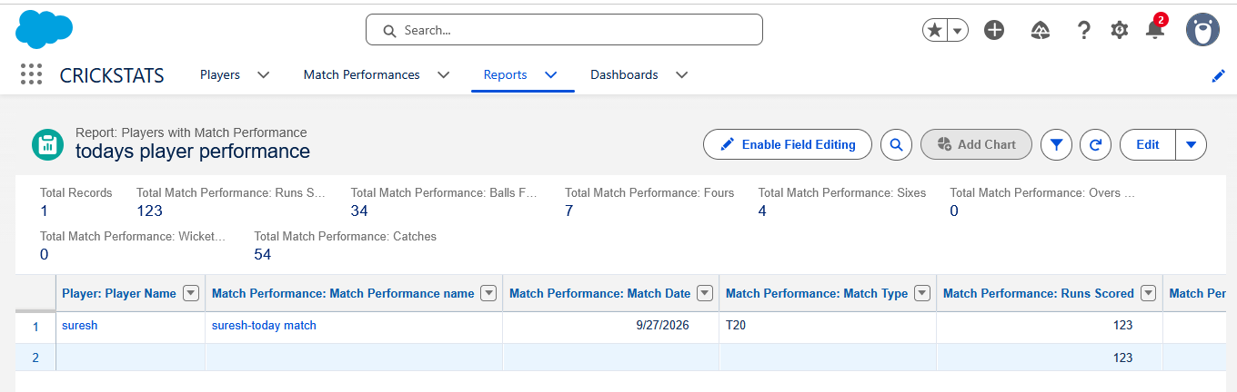

Activity 5 – Save the Report
- Click Save & Run.
- Enter the report name:
Today’s Player Performance
- Select Public Reports or the appropriate CRICKSTATS report folder.
- Click Save.
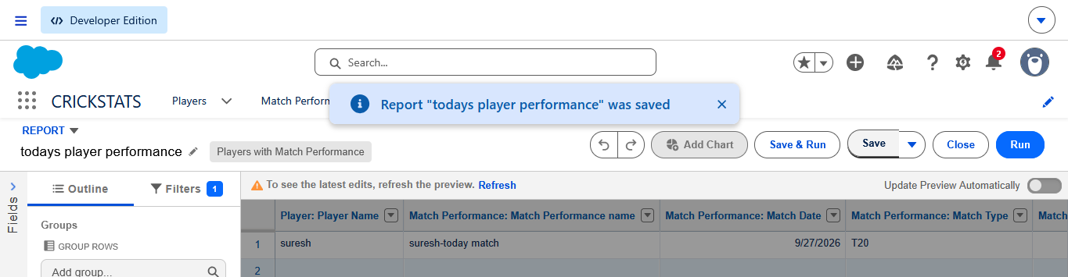

Activity 6 – Verify the Final Report
Open:
Reports → Today’s Player Performance
Verify that:
- The Player field is displayed.
- Match Date is displayed.
- Performance statistics are displayed.
- Match Date = TODAY filter is applied.
- Only today's performance records are shown.

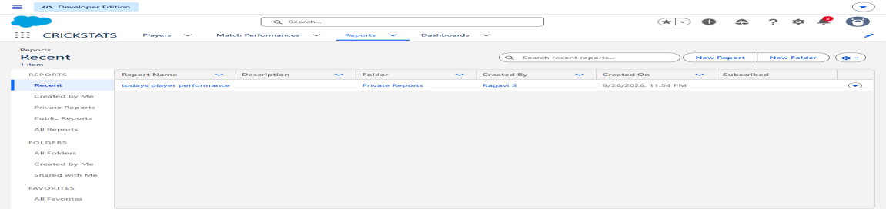

Milestone 7 – Previous Performance Comparison
- Now we will create a report to compare a player's recent performance with their previous match performances. This helps the coach understand whether a player is improving, maintaining, or changing their performance over multiple matches.

Activity 1 – Create the Report
- Open CRICKSTATS.
- Click Reports.
- Click New Report 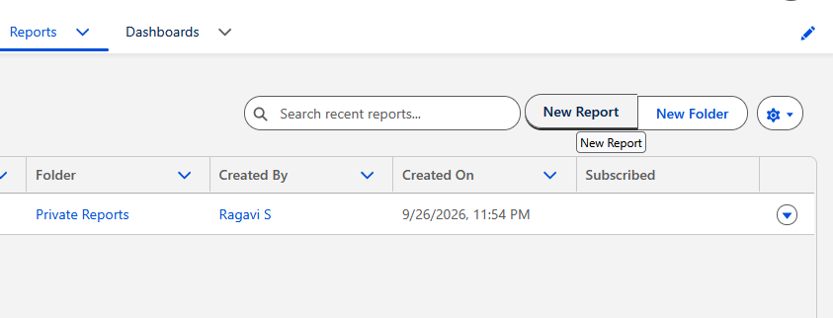
- In the search box, type:Match Performance
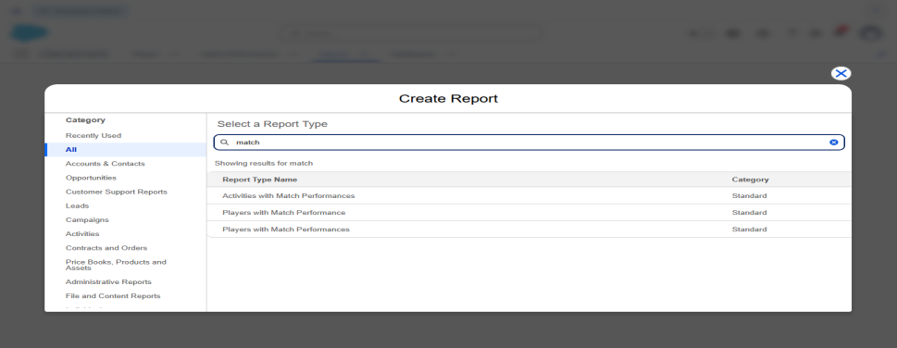
- Select Players with Match Performances.
- Click Start Report.

Activity 2 – Select Columns
Go to Outline → Columns.
Keep/add these fields:
- Player: Player Name
- Match Performance: Match Date
- Match Performance: Match Type
- Runs Scored
- Balls Faced
- Fours
- Sixes
- Wickets Taken
- Catches
- Match Result
Remove unnecessary fields such as Player ID.

Activity 3 – Group by Player
This is important because we want to see each player's performance history together.
In Outline, find Group Rows.
Click Add Group and select:
Player Name
Now the report will organize the performances player-wise.
For example:
Suresh
- 27/09/2026 – 72 Runs
- 25/09/2026 – 58 Runs
- 22/09/2026 – 45 Runs
This makes previous performances easy for the coach to compare.
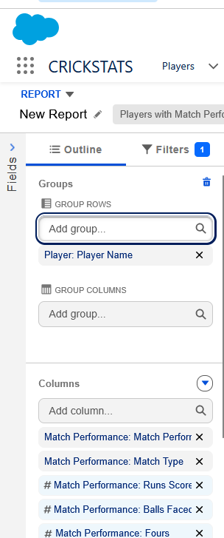

Activity 4 – Sort by Match Date
Click the dropdown beside:
Match Date
Select:
Sort Descending
Now the latest match will appear first and older matches will appear below it.
So the coach can easily see:
Latest Performance → Previous Performance → Older Performance
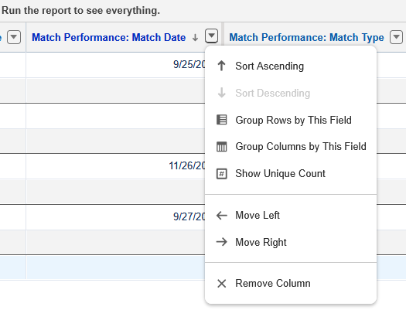

Activity 5 – Run the Report
Click Run.
Check whether:
- Players are grouped correctly.
- Match dates are displayed.
- Latest match appears first.
- Runs and other statistics are visible.
- Multiple performances of the same player are shown together.
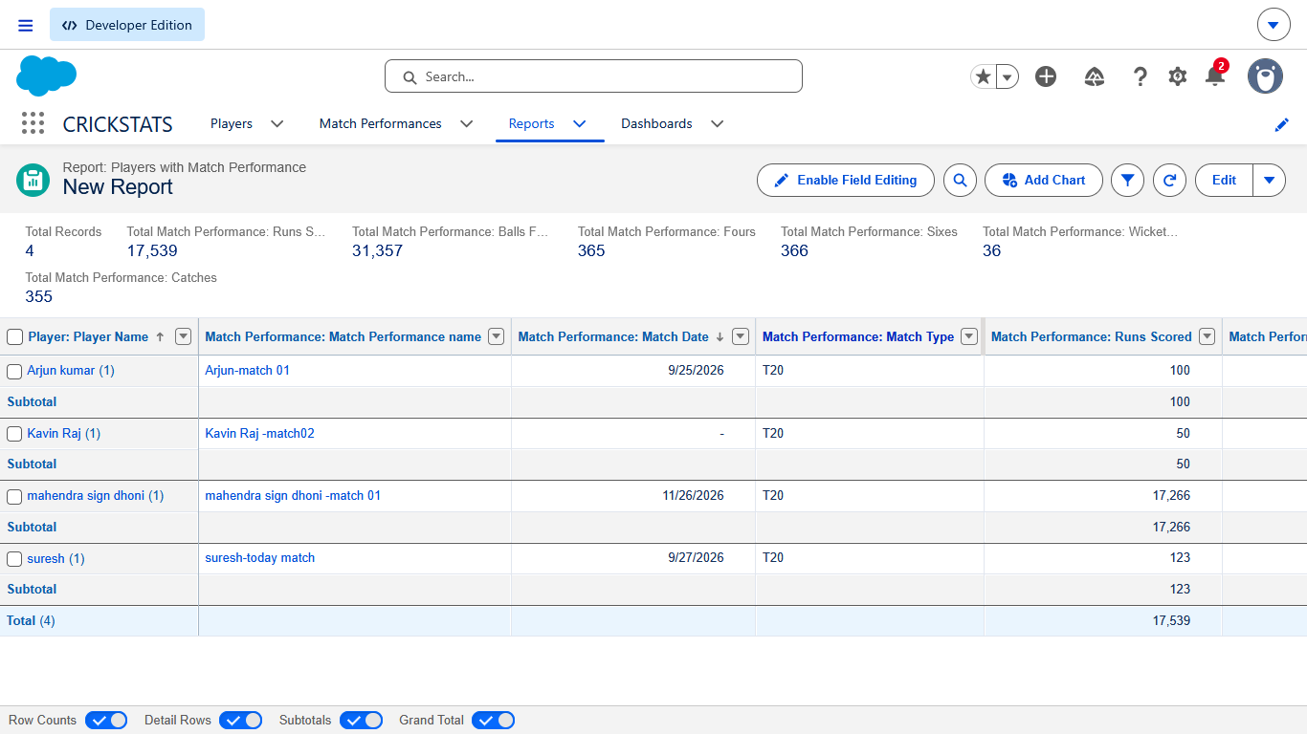

Activity 6 – Save the Report
Click Save & Run.
Use:
Report Name:
Player Performance Comparison
Then click Save.
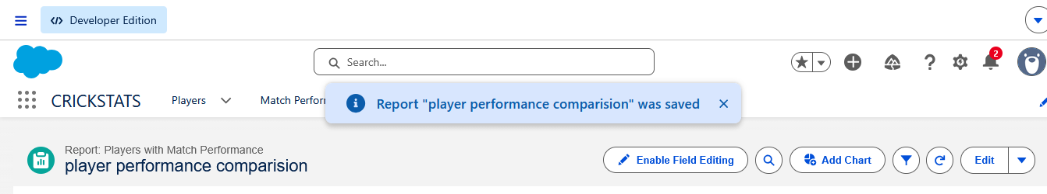

Milestone 8 – Player Comparison & Team Insights
- The purpose of this milestone is to help the Cricket Coach compare players based on their overall match performance. The coach can view statistics such as matches played, total runs, average score, fours, sixes, and wickets.

Activity 1 – Create Player Comparison Report
- Open CRICKSTATS.
- Click Reports.
- Click New Report.
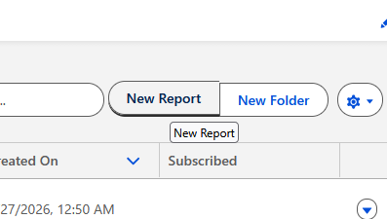
- Search for Players.
- Select the Players report type.
- Click Start Report.
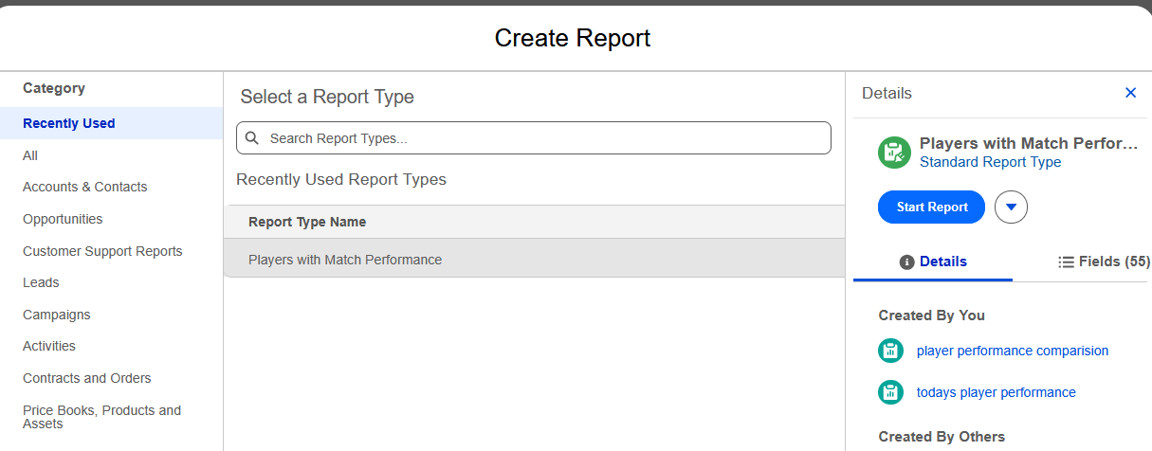

Activity 2 – Add Player Statistics
Go to Outline → Columns.
Add these fields:
- Player Name
- Team
- Role
- Player Status
- Matches Played
- Total Runs
- Average Score
- Total Fours
- Total Sixes
- Total Wickets
These fields allow the coach to compare the overall performance of different players.

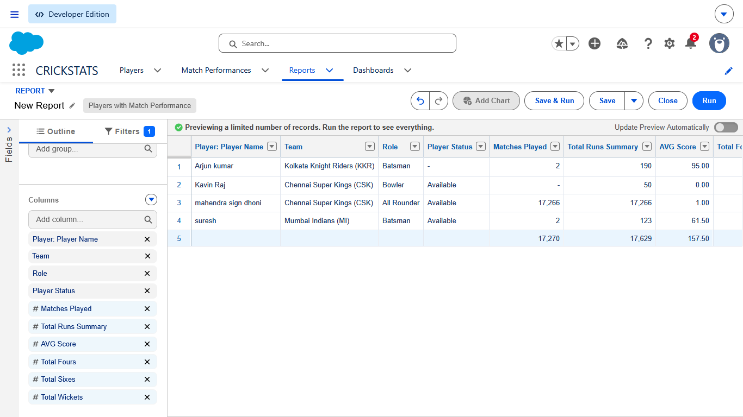

Activity 3 – Group Players by Team
In Outline → Group Rows:
- Click Add Group.
- Select Team.
Now players will be organized according to their teams.
Example:
Chennai Super Kings
- Suresh
- Arjun Kumar
Mumbai Indians
- Kavin Raj
- Another Player
This provides a simple team-wise player insight.
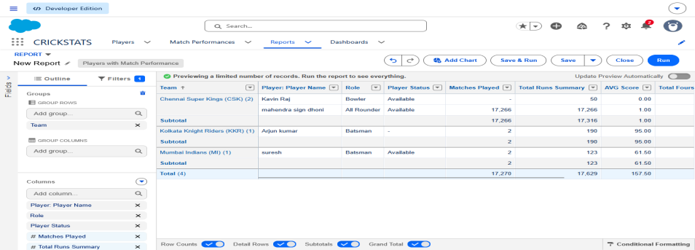

Activity 4 – Sort Player Performance
For Total Runs, select:
Sort Descending
This will display players with higher total runs first.
⚠This is only to organize the report for easier viewing; it does not automatically decide team selection.
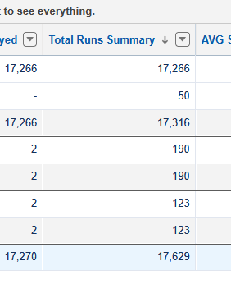

Activity 5 – Run and Verify
Click Run.
Check that the report displays:
- Player Name
- Team
- Role
- Matches Played
- Total Runs
- Average Score
- Fours
- Sixes
- Wickets
Also verify that players are grouped under their respective teams.
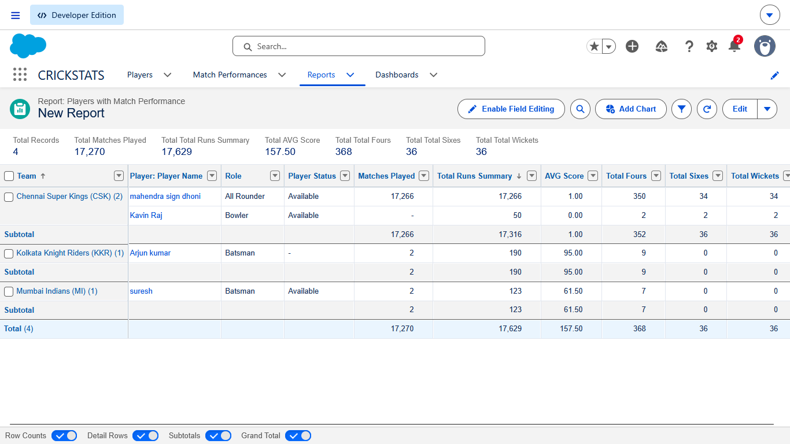

Activity 6 – Save the Report
Click Save & Run.
Use the report name:
Player Comparison & Team Insights
Click Save.
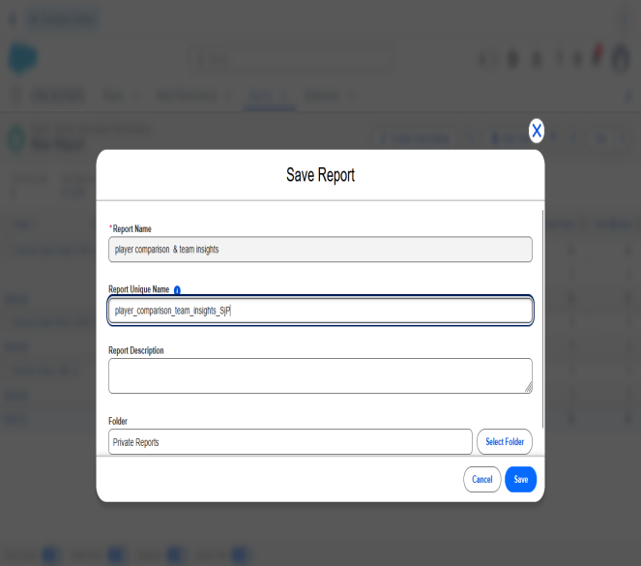
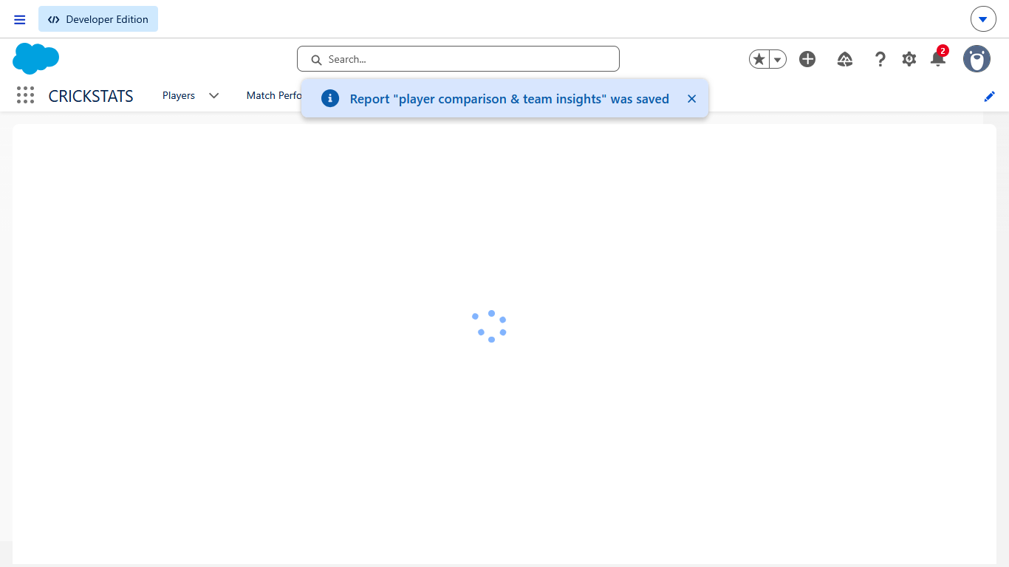

Milestone 9 – Coach Performance Flow
Now we will create a Salesforce Flow for the coach.

Objective
- The flow allows the coach to select a team and view the players belonging to that team along with their performance information in one place.
Flow:
Select Team → Get Players → Display Player Performance

Activity 8.1 – Open Flow Builder
Go to:
Setup → Quick Find → Flows
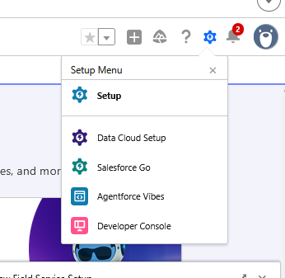
Then:
- Click Flows
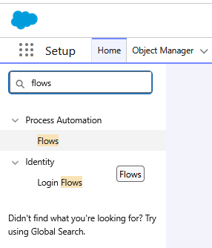
- Click New Flow
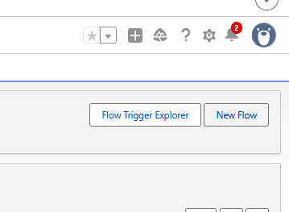
- Select Screen Flow
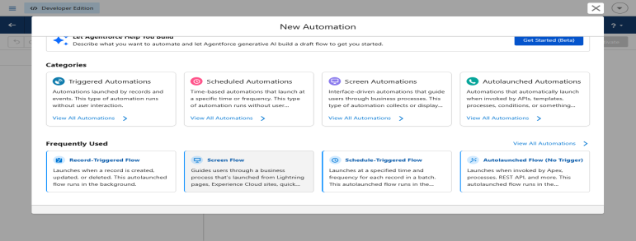
- Click Create

Activity 2 – Create the Team Selection Screen
In Flow Builder:
- Click the + button.
- Select Screen.
- Screen Label: Select Team
- Add a Picklist component.
Set:
Label: Select Team
For the choices, use your existing Team values:
- Chennai Super Kings
- Mumbai Indians
- Royal Challengers Bangalore
- Kolkata Knight Riders
- Delhi Capitals
- Punjab Kings
- Rajasthan Royals
- Sunrisers Hyderabad
Set the component as Required.
Click Done.
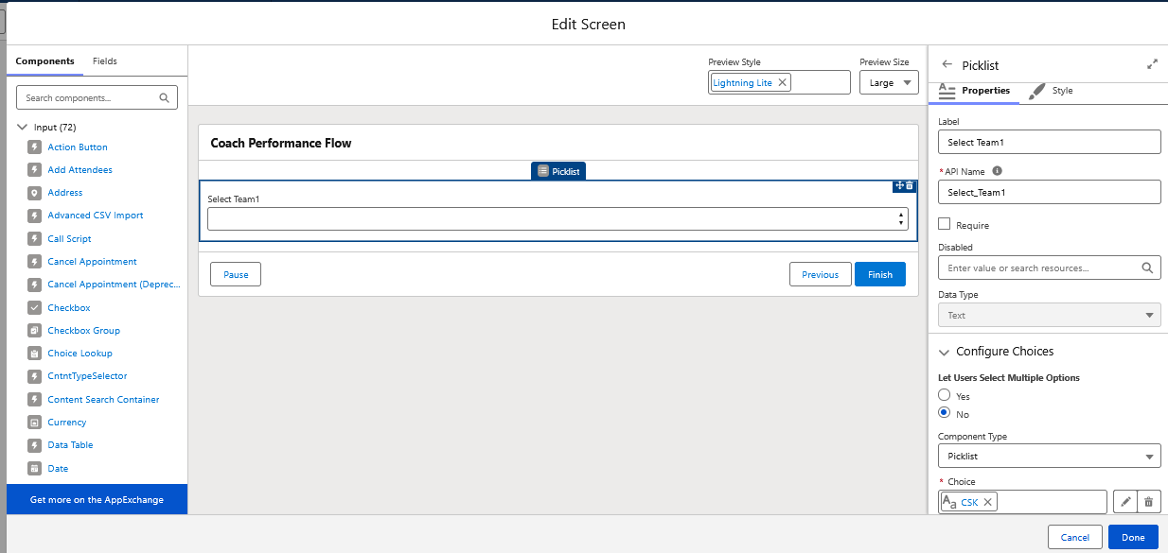

Activity 3 – Get Players
Click the + after the Screen element.
Select:
Get Records
Set:
Object: Player
Under conditions:
Team → Equals → Select Team
Here, Select Team should be the value stored from the previous Screen component.
Choose:
Store All Records
Click Done.
This allows the Flow to retrieve all players belonging to the selected team.
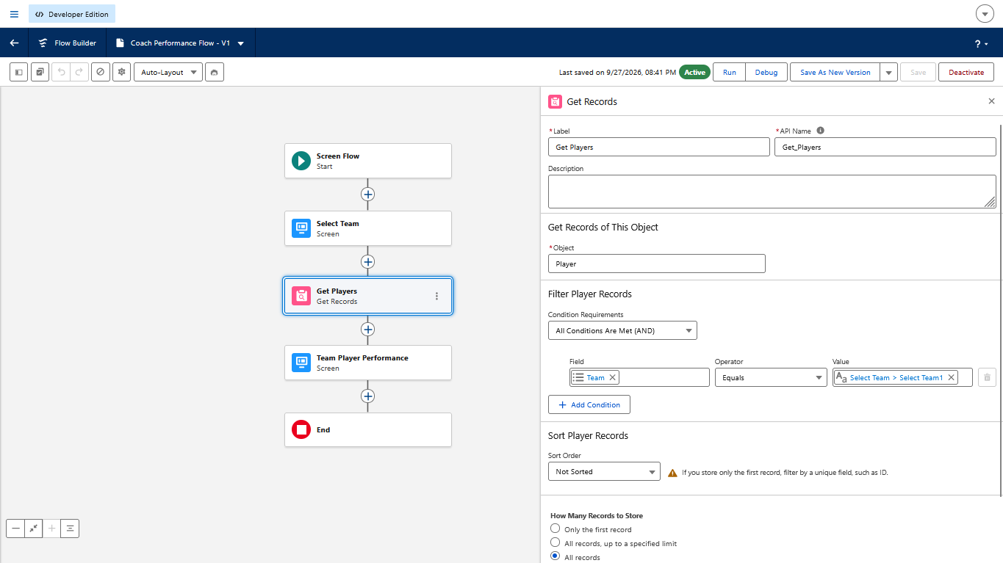

Activity 4 – Display Player Information
Click + after Get Records.
Select:
Screen
Screen Label:
Team Player Performance
Add a Display Text component.
You can display information such as:
Selected Team: selected team name
Then add a Data Table component if available in your Flow Builder.
Use the records obtained from:
Get Players
Select columns such as:
- Player Name
- Role
- Team
- Player Status
- Matches Played
- Total Runs
- Average Score
- Total Wickets
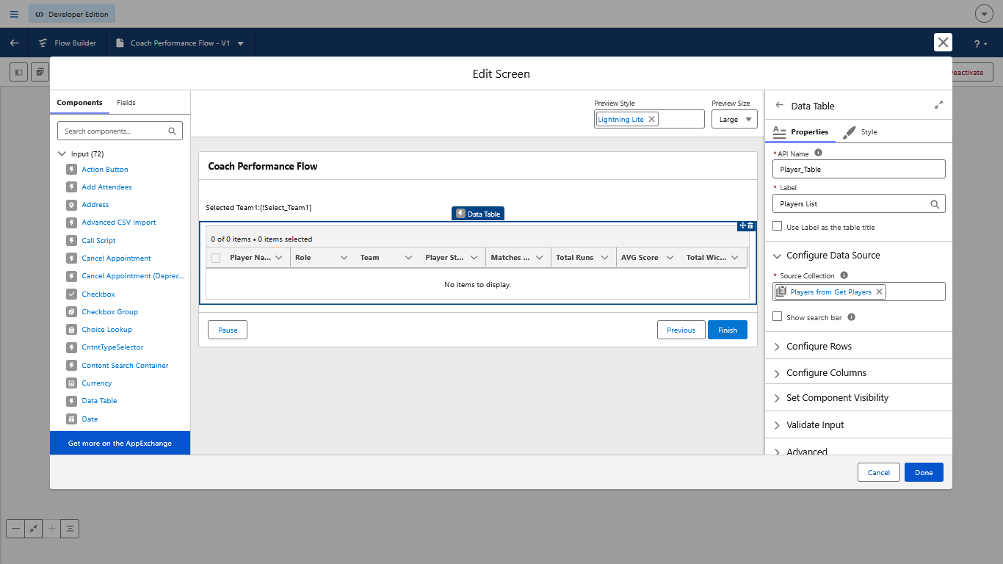

Activity 5 – Save the Flow
Click Save.
Flow Label:
Coach Player Performance Flow
Then click:
Save
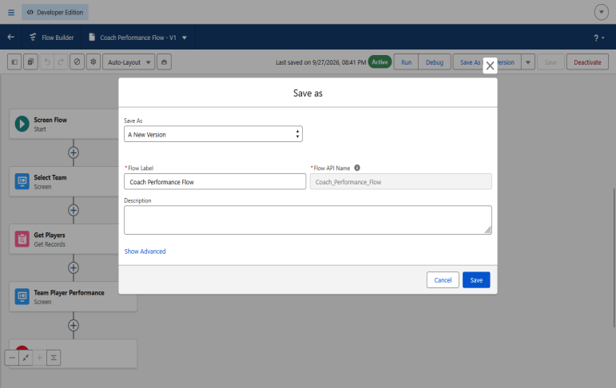

Activity 6 – Activate the Flow
After saving:
- Click Activate.
- Confirm activation.
The Flow is now available for use.
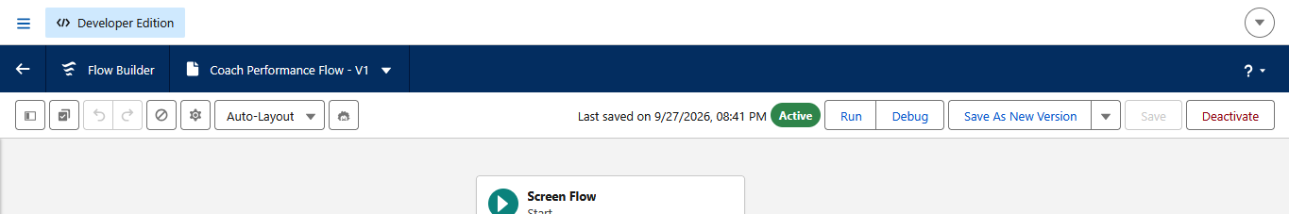

Activity 7 – Test the Flow
Click Run.
Select a team, for example:
Chennai Super Kings
The Flow should retrieve the players belonging to that team and display their available performance information.
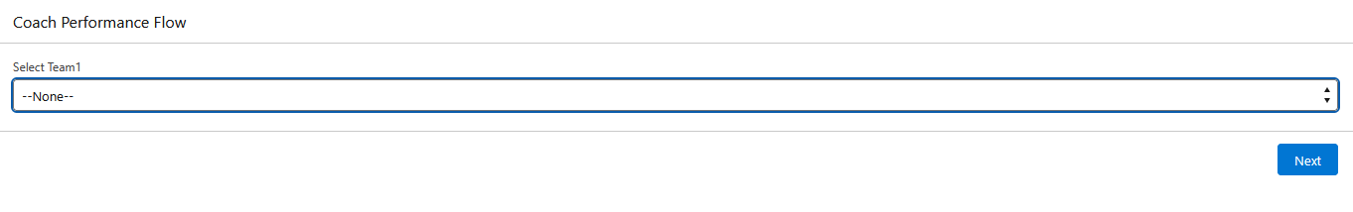
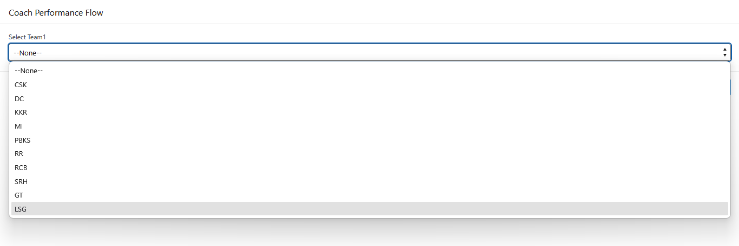
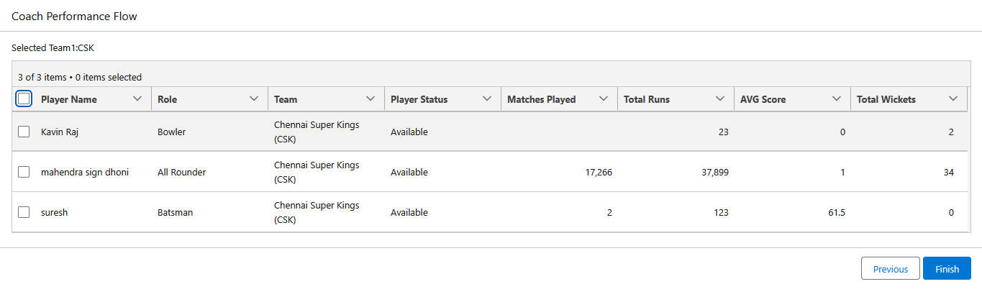

Milestone 10 – Performance Reports
- Now we will create the main performance reports that the coach can use to analyze players and teams.

Objective
- The objective of this milestone is to provide the coach with different reports for today’s performance, top run scorers, top wicket takers, player comparison, and team-wise performance.

Activity 1 – Create Top Run Scorers Report
Go to:
CRICKSTATS → Reports → New Report
Select:
Players with Match Performances
Click Start Report.

Add Columns
Keep:
- Player Name
- Match Date
- Runs Scored
- Balls Faced
- Fours
- Sixes
- Match Result

Sort Runs
Click the dropdown beside Runs Scored.
Select:
Sort Descending
This displays the higher run values first.
Save as:
Top Run Scorers

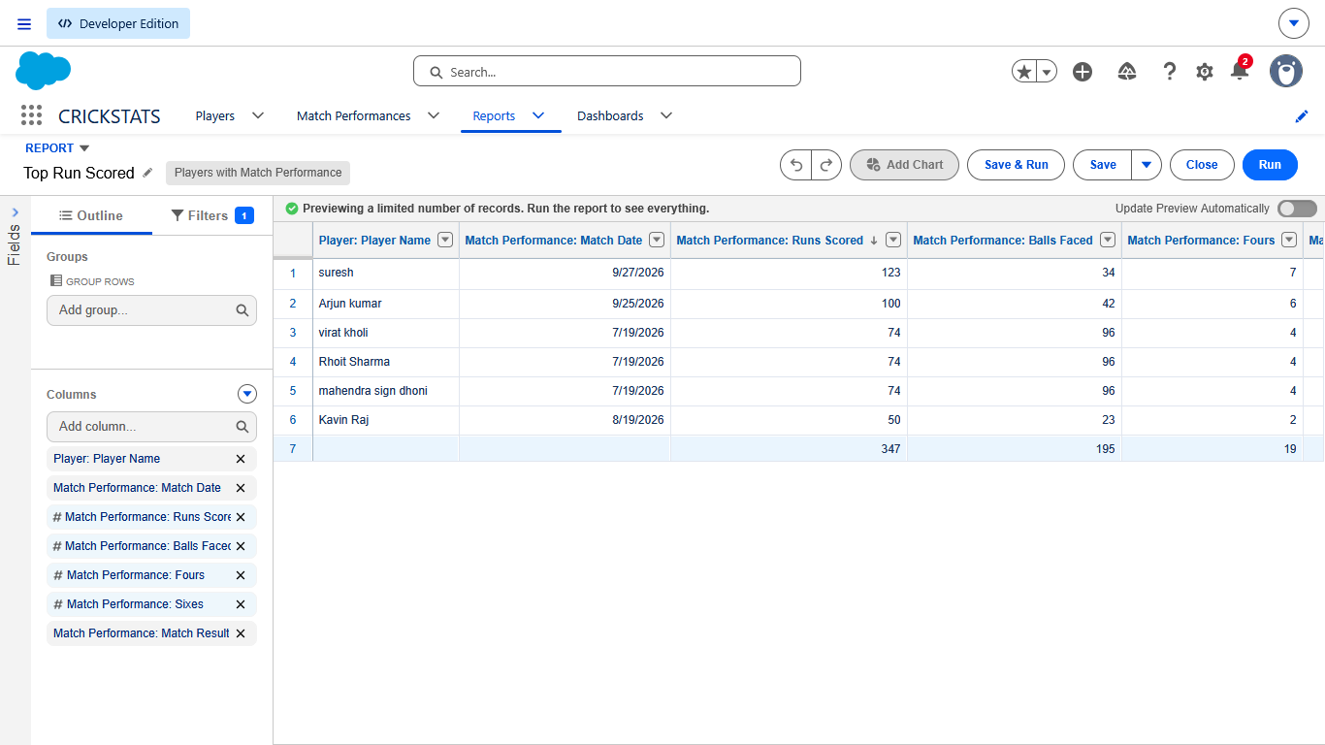

Activity 2 – Create Top Wicket Takers Report
Create another report using:
Players with Match Performances
Add:
- Player Name
- Match Date
- Match Type
- Overs Bowled
- Wickets Taken
- Runs Conceded
- Catches
- Match Result
Sort:
Wickets Taken → Descending
Save as:
Top Wicket Takers
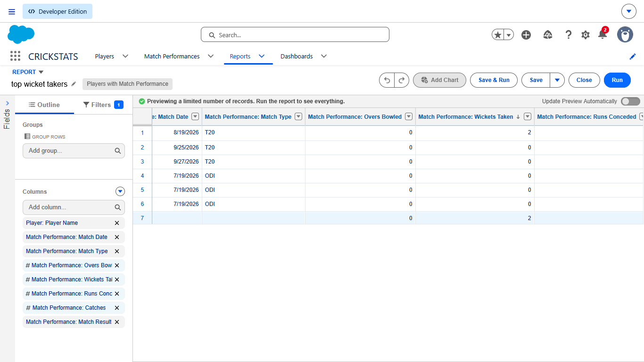

Activity 3 – Create Team-wise Performance Report
Create a new report using:
Players with Match Performances
Add:
- Player Name
- Team
- Match Date
- Runs Scored
- Fours
- Sixes
- Wickets Taken
- Catches
Under Group Rows, select:
Team
This organizes the performance information team-wise.
Save as:
Team-wise Player Performance
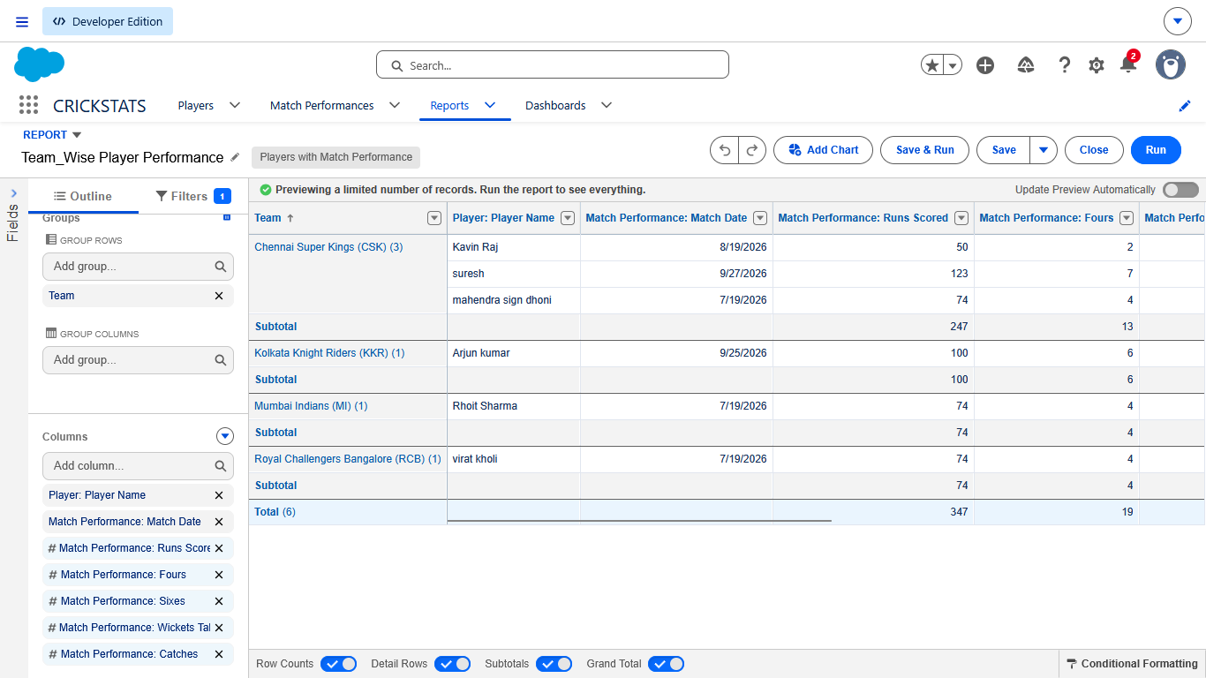

Activity 4 – Create Available Players Report
Create a new report using:
Players
Add:
- Player Name
- Player Number
- Role
- Team
- Player Status
- Matches Played
- Total Runs
- Average Score
Add a filter:
Player Status = Available
Save as:
Available Players
This allows the coach to quickly view players who are currently marked as available.
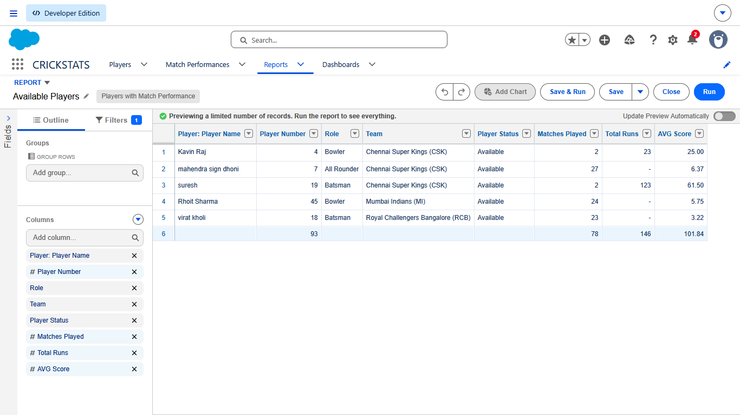

Activity 5 – Create Player Performance Comparison Report
We already created the comparison report in Milestone 6.
Use:
Player Performance Comparison
This report shows multiple performances of players and helps the coach compare recent and previous matches.

Activity 6 – Verify All Reports
Go to:
Reports → Recent
You should now have reports such as:
- Today’s Player Performance
- Player Performance Comparison
- Player Comparison & Team Insights
- Top Run Scorers
- Top Wicket Takers
- Team-wise Player Performance
- Available Players
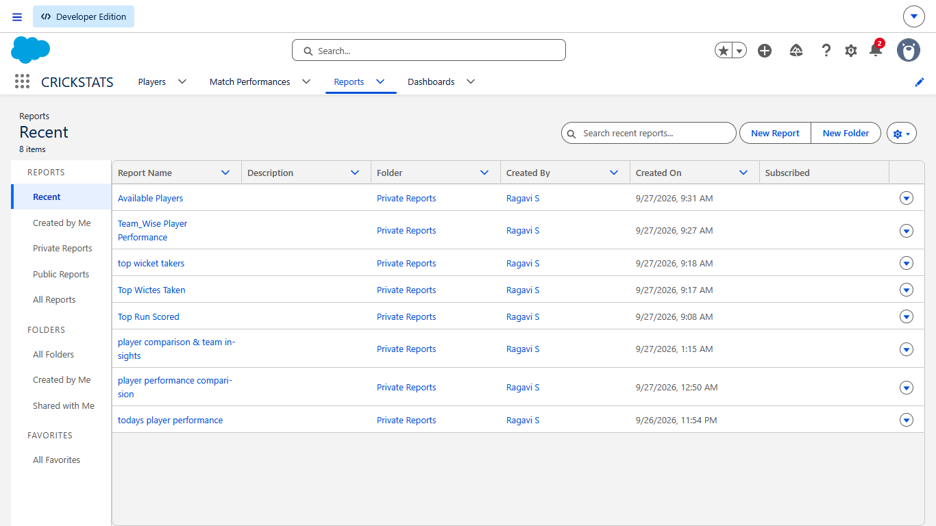

Milestone 11 – Coach Dashboard
- Now we will create the Coach Dashboard in Salesforce. This dashboard will bring the important CRICKSTATS performance information into one place.

Objective
- The objective is to provide the coach with a visual summary of player performance, runs, wickets, team performance, and player availability without opening each report separately.

Activity 1 – Open Dashboards
- Open CRICKSTATS.
- Click Dashboards.
- Click New Dashboard.
Enter:
Dashboard Name:
CRICKSTATS Coach Dashboard
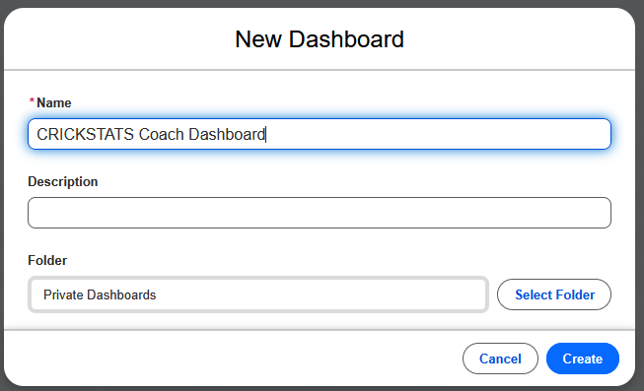
Description:
Dashboard for monitoring player and team performance.
Click Create.

Activity 2 – Add Today’s Performance Component
Click:
+ WIDGET AND SELECT CHART OR TABLE
Select the report:
Today’s Player Performance
Choose a suitable component such as:
Table
Display fields such as:
- Player
- Runs Scored
- Fours
- Sixes
- Wickets Taken
- Catches
Click Add.

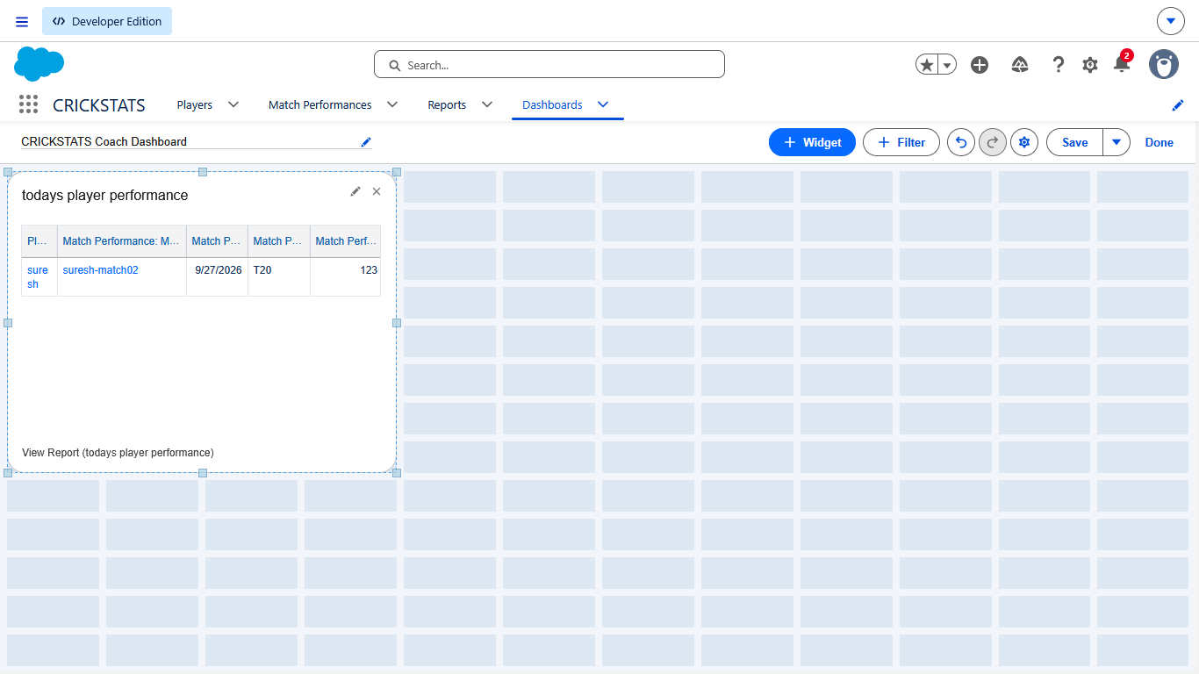

Activity 3 – Add Top Run Scorers
Click:
+ WIDGET AND SELECT CHART OR TABLE
Select:
Top Run Scorers
Choose a Bar Chart.
Set:
- X-Axis: Player Name
- Y-Axis: Runs Scored
Click Add.
This gives the coach a visual comparison of run-scoring performance
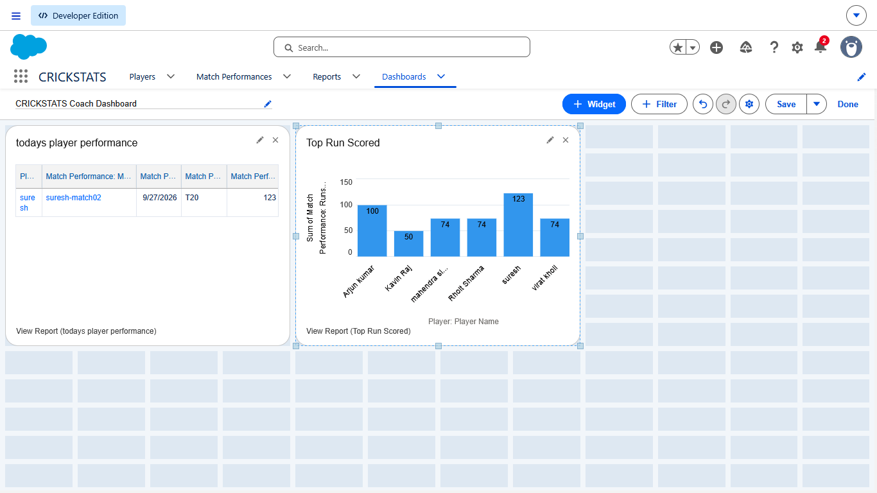

Activity 4 – Add Top Wicket Takers
Click:
+ WIDGET AND SELECT CHART OR TABLE
Select:
Top Wicket Takers
Choose a Bar Chart.
Set:
- X-Axis: Player Name
- Y-Axis: Wickets Taken
Click Add.
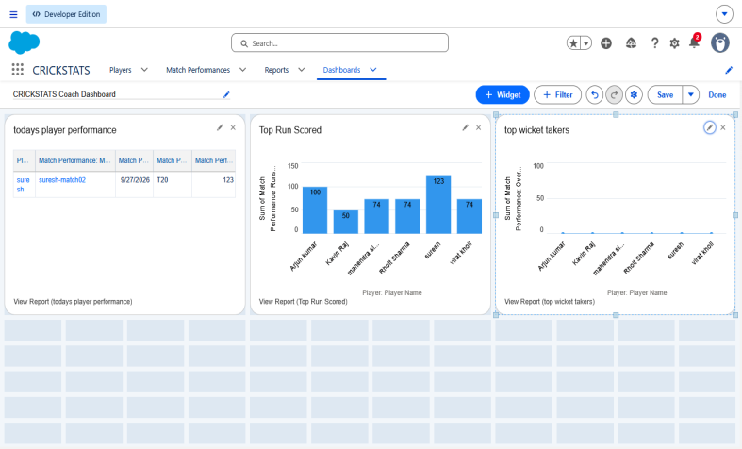

Activity 5 – Add Team-wise Performance
Click:
+ WIDGET AND SELECT CHART OR TABLE
Select:
Team-wise Player Performance
Choose a chart such as:
Bar Chart
Use:
- Group: Team
- Value: Runs Scored
Click Add.
This allows the coach to view performance information team-wise.
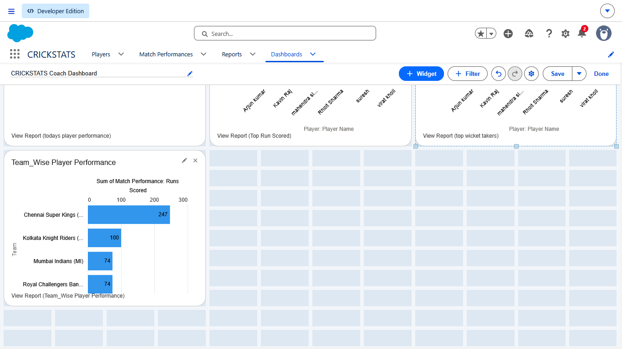

Activity 6 – Add Available Players
Click:
+ WIDGET AND SELECT CHART OR TABLE
Select:
Available Players
Choose:
Table
Display:
- Player Name
- Role
- Team
- Player Status
- Matches Played
- Total Runs
- Average Score
Click Add.
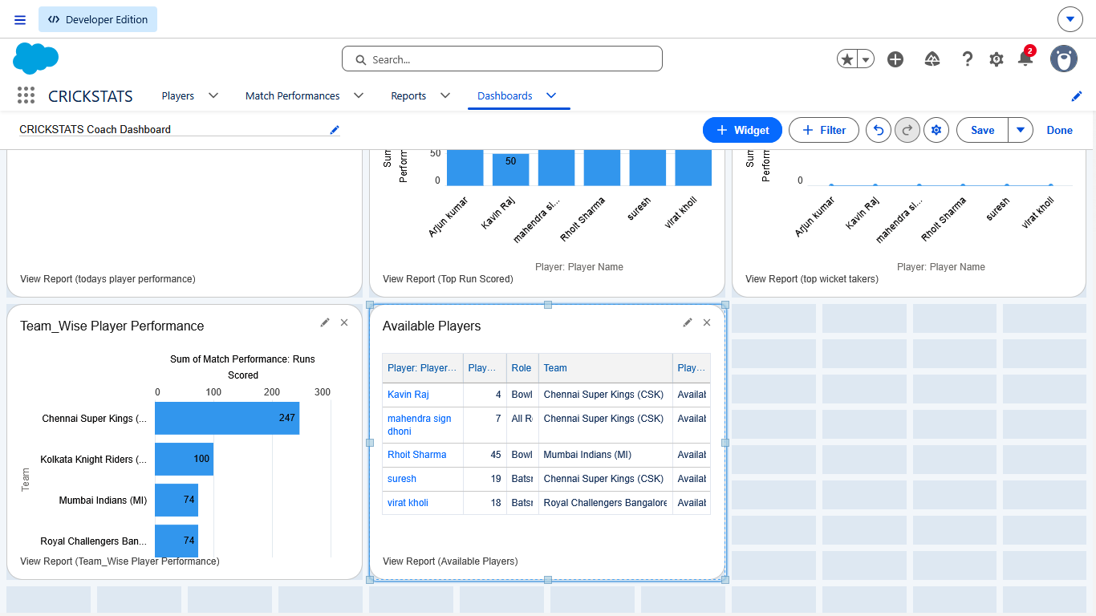

Activity 7 – Arrange the Dashboard
Arrange the components so that the most important information is easy to see.
A simple layout can be:
Top:
Today's Player Performance
Middle:
Top Run Scorers | Top Wicket Takers
Bottom:
Team-wise Performance | Available Players
You can resize the components using the dashboard layout controls.
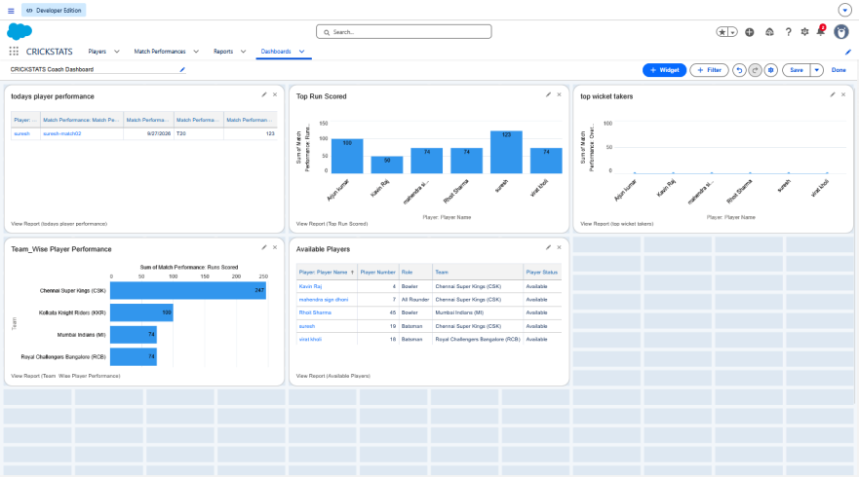

Click:
Save
Then click:
Done
Open the dashboard again and verify that all components are displaying data correctly.
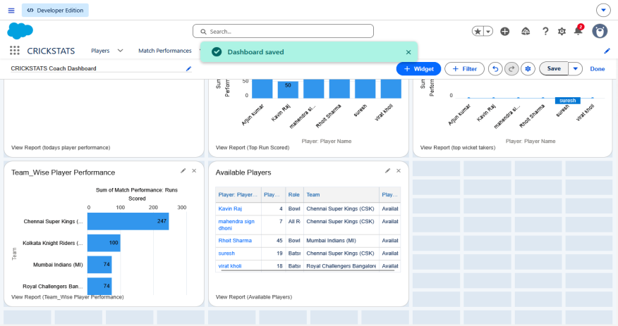

Milestone 12 – Tomorrow Match / Training Planning
- Now we will create the Team Planning module in Salesforce. This allows the coach to plan tomorrow’s match or training session based on recent player performance.

Objective
The coach should be able to record:
- Planning date
- Team
- Opponent
- Match/Training type
- Selected player
- Selection status
- Coach notes
This supports your user story:
Today’s Performance → Previous Performance → Tomorrow’s Planning

Activity 1 – Create Team Plan Object
Go to:
Setup → Object Manager → Create → Custom Object
Enter:
Label: Team Plan
Plural Label: Team Plans
Record Name: Team Plan Name
Data Type: Text
Enable:
- ☑ Allow Reports
- ☑ Allow Search
Click Save.
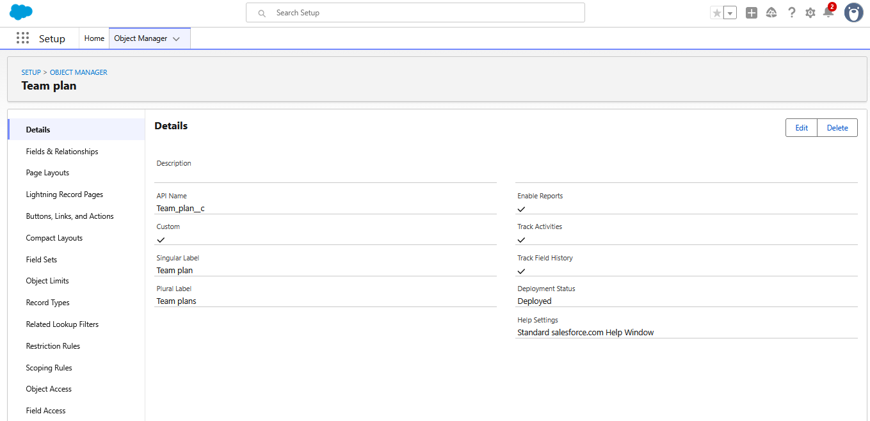

Activity 2 – Create Plan Date
Go to:
Team Plan → Fields & Relationships → New
Select:
Date
Click Next.
Enter:
Field Label: Plan Date
Click:
Next → Next → Save
This field stores the date for the upcoming match or training.
Example:
27/09/2026
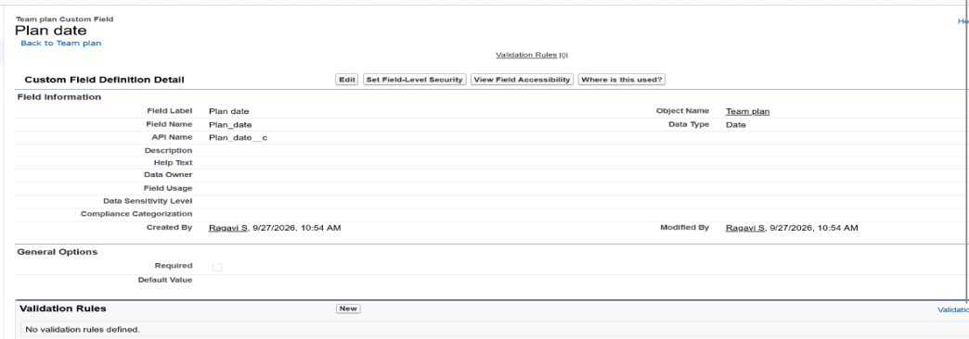

Activity 3 – Create Team Field
Create another field:
New → Picklist
Field Label:
Team
Add your existing teams:
- Chennai Super Kings
- Mumbai Indians
- Royal Challengers Bangalore
- Kolkata Knight Riders
- Delhi Capitals
- Punjab Kings
- Rajasthan Royals
- Sunrisers Hyderabad
Click:
Next → Save

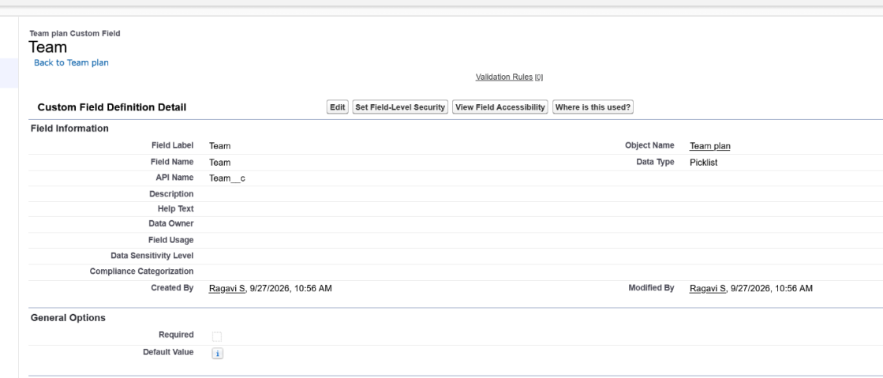

Activity 4 – Create Opponent Field
Create:
New → Text
Field Label:
Opponent
Length:
100
Click:
Next → Save
Example:
Mumbai Indians
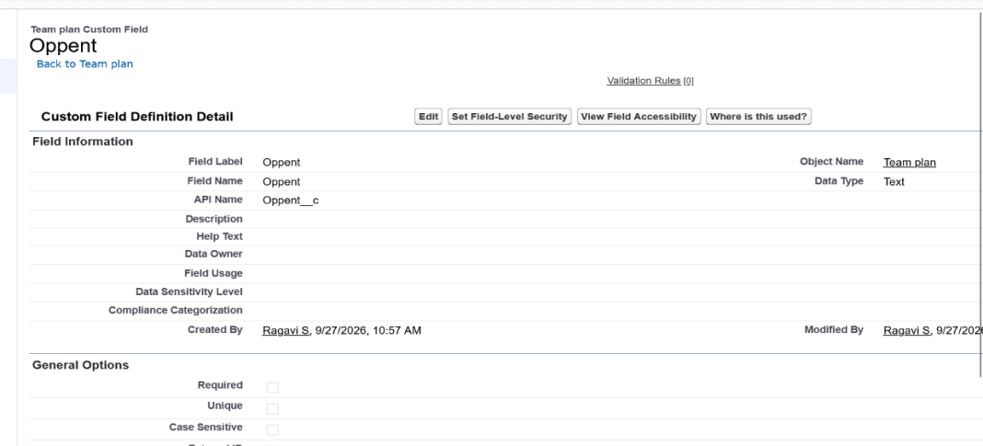

Activity 5 – Create Plan Type
Create:
New → Picklist
Field Label:
Plan Type
Values:
- Match
- Training
- Practice
Click:
Next → Save
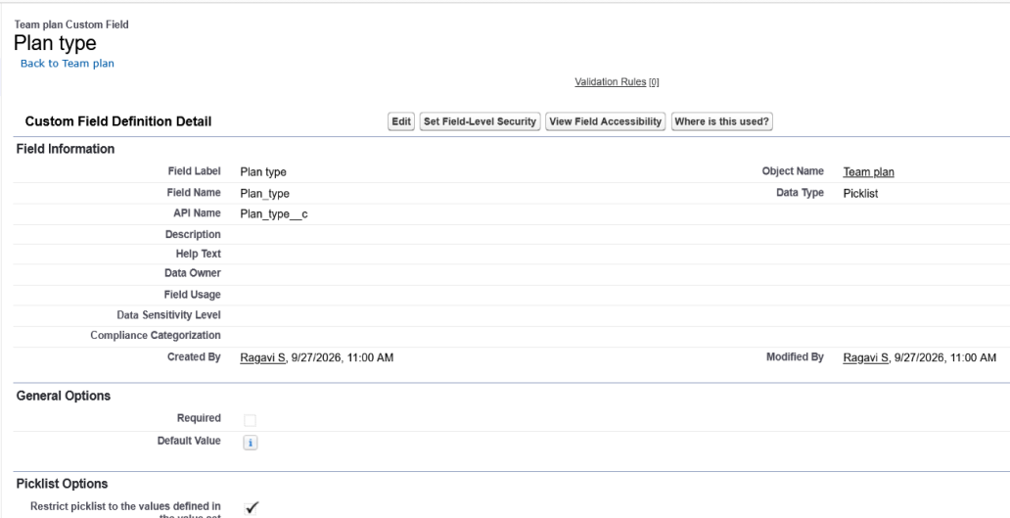

Activity 6 – Create Selected Player
Create:
New → Lookup Relationship
Related To:
Player
Field Label:
Selected Player
Click:
Next → Next → Save
Now the coach can select a player from the existing Player records.
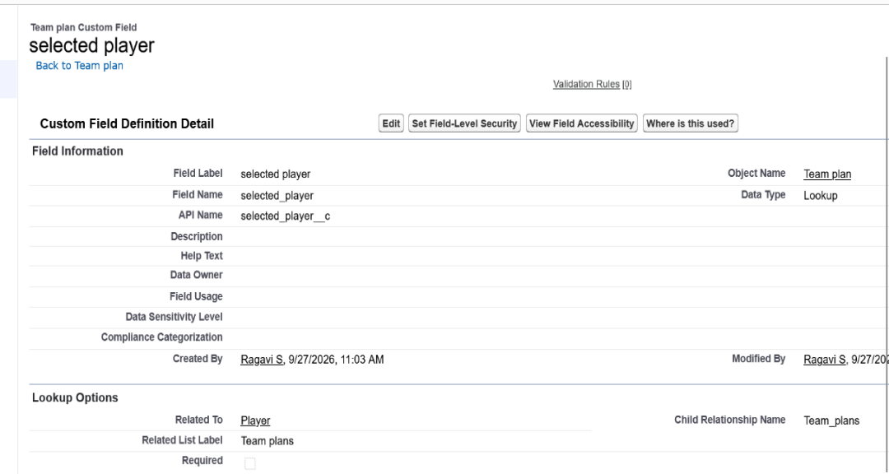

Activity 7 – Create Selection Status
Create:
New → Picklist
Field Label:
Selection Status
Values:
- Selected
- Reserve
- Not Selected
Click:
Next → Save
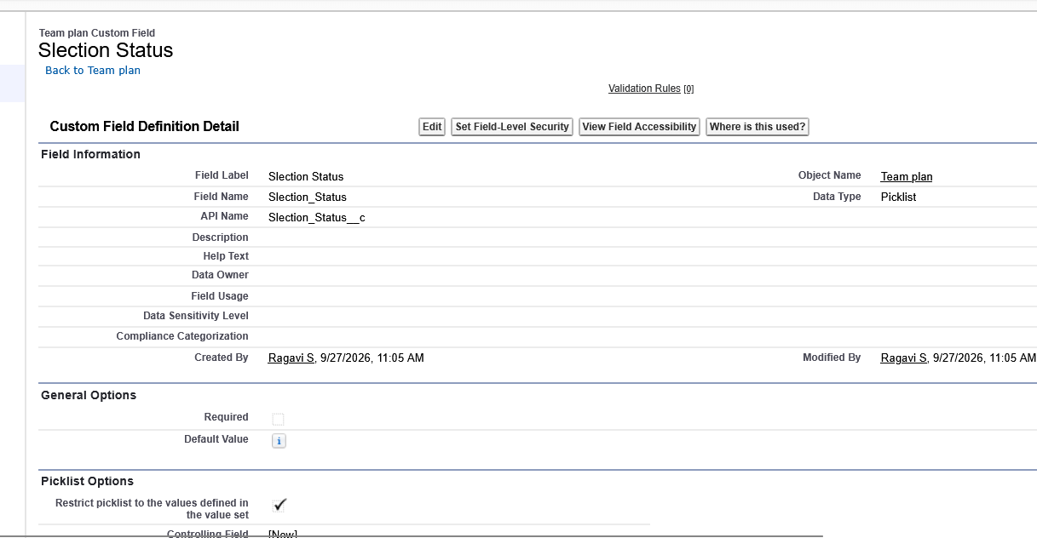

Activity 8 – Create Coach Notes
Create:
New → Long Text Area
Field Label:
Coach Notes
Click:
Next → Save
Example:
Good recent batting performance. Suitable for the upcoming match.

Activity 11.9 – Create a Team Plan Record
Go to:
App Launcher → CRICKSTATS → Team Plans → New
Enter an example:
Team Plan Name: Tomorrow Match Plan
Plan Date: 28/09/2026
Team: Chennai Super Kings
Opponent: Mumbai Indians
Plan Type: Match
Selected Player: Suresh
Selection Status: Selected
Coach Notes: Good recent performance and suitable for the upcoming match.
Click Save.
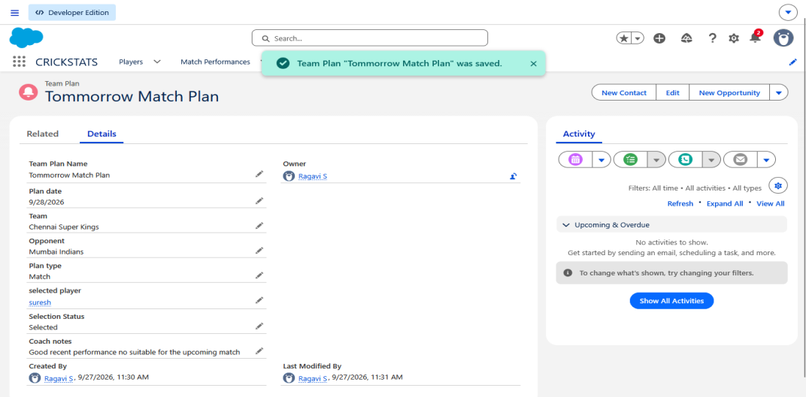

Activity 10 – Verify the Team Plan
Open the created Team Plan record.
Check that all information is displayed:
- Plan Date
- Team
- Opponent
- Plan Type
- Selected Player
- Selection Status
- Coach Notes
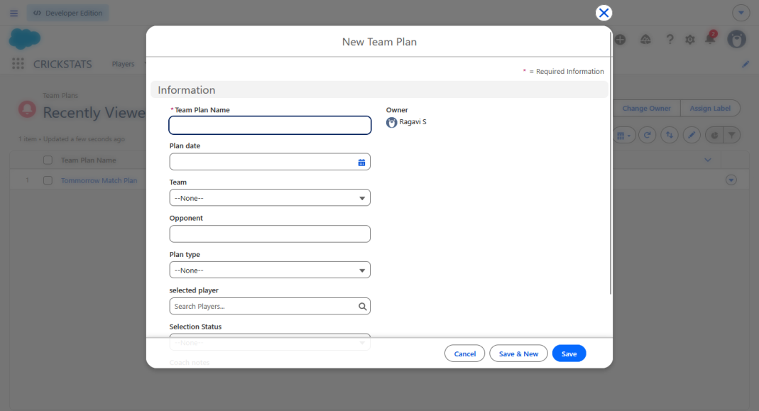

Milestone 13 – Team Selection
- Now we will create the Team Selection module in Salesforce. This allows the coach to record which players are Selected, Reserve, or Not Selected for an upcoming match.

Objective
- The coach can use the player's recent performance, previous performance, and current availability to record the planned team selection.
Flow:
Player Performance → Team Plan → Player Selection → Selection Status

Activity 12.1 – Open Team Plans
Go to:
App Launcher → CRICKSTATS → Team Plans
Open the Tomorrow Match Plan that you created in Milestone 11.
Click Edit.
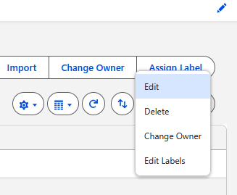

Activity 2 – Select Players
In the Selected Player field, select the required player.
For example:
Selected Player: Suresh
Then set:
Selection Status: Selected
Add a suitable note:
Coach Notes:
Player has shown good recent performance and is selected for the upcoming match.
Click Save.
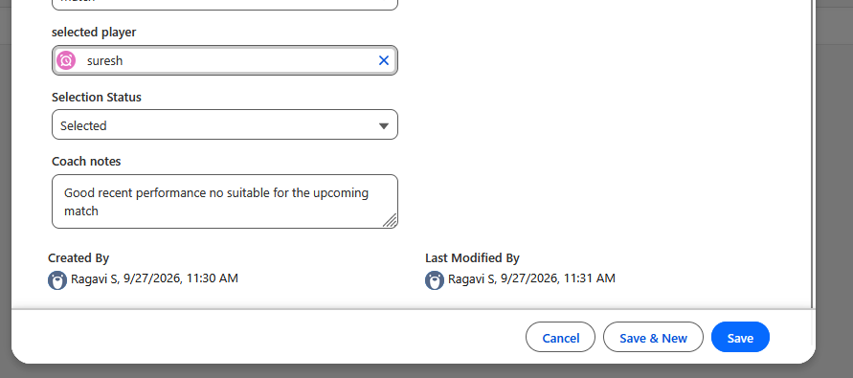

Activity 12.3 – Add Reserve Player
Create another Team Plan record.
Example:
Team Plan Name: Tomorrow Match – Reserve
Plan Date: 28/09/2026
Team: Chennai Super Kings
Opponent: Mumbai Indians
Plan Type: Match
Selected Player: Arjun Kumar
Selection Status: Reserve
Coach Notes:
Player is kept as a reserve based on current team requirements.
Click Save.
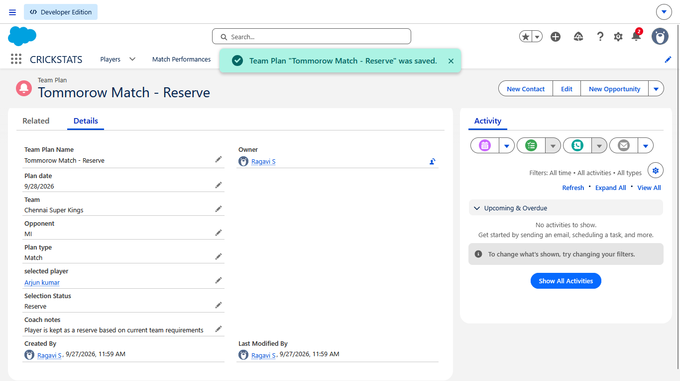

Activity 12.4 – Record Not Selected Player
Create another record for a player who is not selected.
Example:
Team Plan Name: Tomorrow Match – Not Selected
Plan Date: 28/09/2026
Team: Chennai Super Kings
Opponent: Mumbai Indians
Plan Type: Match
Selected Player: Kavin Raj
Selection Status: Not Selected
Coach Notes:
Player is not included in the current match plan.
Click Save.
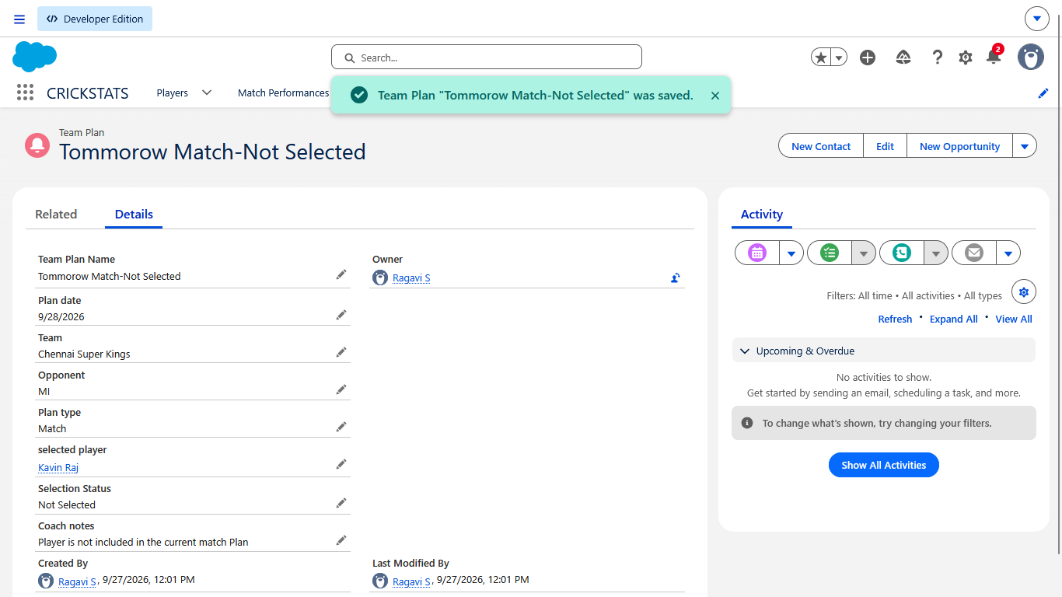

Activity 5 – Verify Team Selection
Go to:
Team Plans → List View
Check the records.
You should now have players with different statuses:
- Selected
- Reserve
- Not Selected
This gives the coach a clear record of the planned team selection.

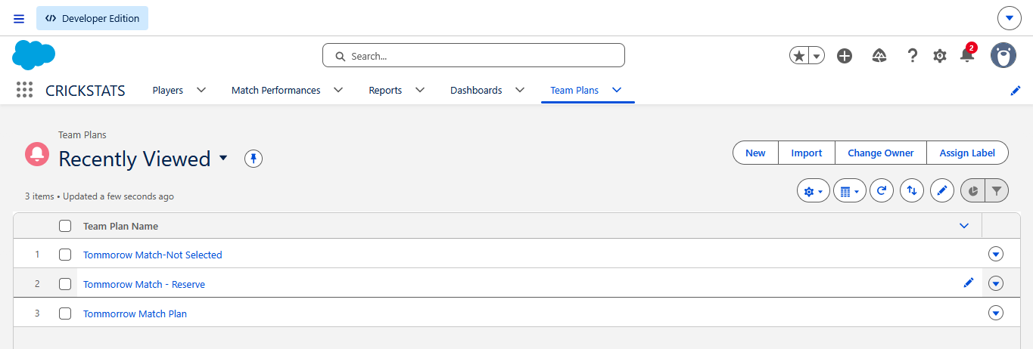

Activity 12.6 – Create Team Selection Report
To make the selection easier to view:
Go to:
Reports → New Report
Select:
Team Plans
Click Start Report.
Add these columns:
- Team Plan Name
- Plan Date
- Team
- Opponent
- Plan Type
- Selected Player
- Selection Status
- Coach Notes
Add a filter:
Plan Date = Tomorrow
If the dynamic Tomorrow option is unavailable, use the exact planned date, such as:
28/09/2026

Click Run.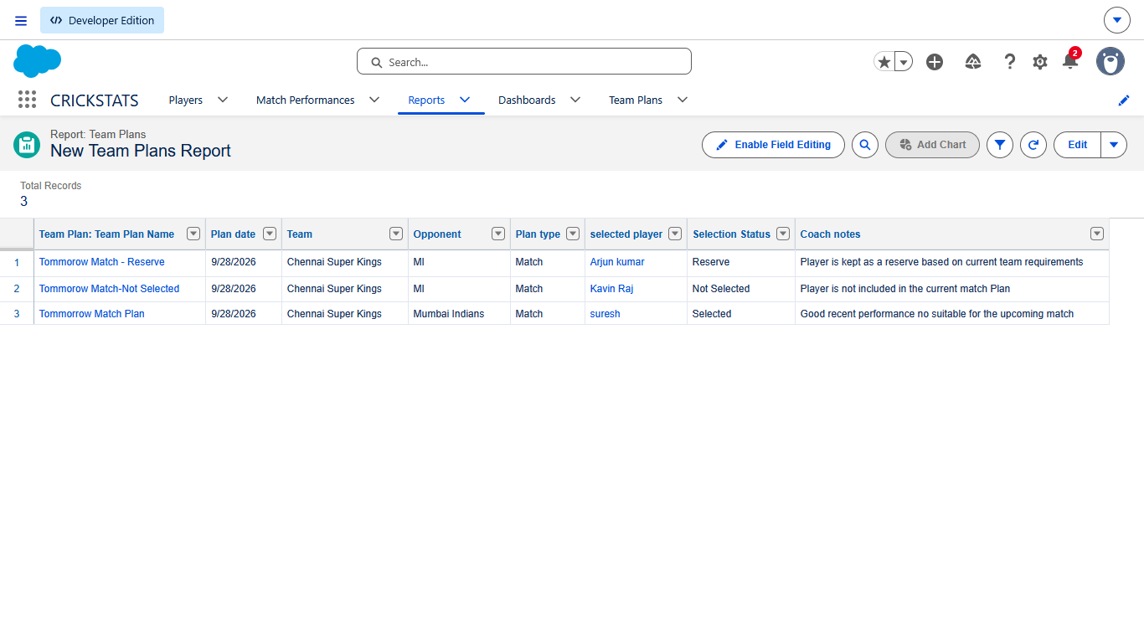
Save as:
Tomorrow Team Selection
